
A REPORT
On

“Comparative Analysis of Sharekhan &
Other Stock Broker Companies”

A report submitted in the partial fulfillment of
The requirements of
MBA program of

Kiet School of Management

Distribution List: Submitted by:

Mr. Raman Goel Rohit Srivastava Assistant Manager (Sales) MBA II YEAR
Sharekhan K.I.E.T


INDEX

INTRODUCTION PART

1. Introduction

  - Objectives

  - Methodology

  - Limitations

2. Introduction of stock market

  - Stock market

  - History

  - Ownership

  - Shareholders right
  - Means of financing

  - Trading

  - Selling

  - Technology of trading

  - Types of shares

  - Derivatives

  - Primary market

  - Secondary market

2. Company Profile

2.1 Company Details

3. About Online trading account

3.1 Classic account

3.2 Speed Trade

3.3 Investing advices

COMPARISION PART

4. Different competitors

  - Sharekhan

  - 5 Paisa

  - Kotak Street

  - India bulls

  - ICICIDirect

  - HDFC Sec

5. Requirement for opening an account

  - Documents required

  - Computer Hardware and Software requirement

  - Different charges taken by Sharekhan for its services

ANALYSIS PART

6. Analysis

6.1 Learning about dematerialization
6.1.1 How to convert your security to demat form

6.1.2 Benefits of Deposit

6.1.3 Disadvantages of Dematerialization System

6.1.4 Depository System (working model)

6.1.5 Growth of dematerialization
6.2 Analysis on future of online trading in India
7. Conclusions
8. Reference

ACKNOWLEDGEMENT

I express my sincerest gratitude and thanks to hon’ble, Mr. Raman Goel (assistant manager), for whose kindness I had the precious opportunity of attaining training at Sharekhan. Under his brilliant untiring guidance I could complete the project being undertaken on the “Comparative Analysis of Sharekhan & other stock Broker companies.” successfully in time. His meticulous attention and invaluable suggestions have helped me in simplifying the problem involved in the work. I would also like to thank the overwhelming support of all the people who gave me an opportunity to learn and gain knowledge about the various aspects of the industry.

I would like to thanks Proff.B.B.Das (PRINCIPAL) K.I.E.T School Of Management. Special thanks for his constant enthusiastic encouragement and valuable suggestions without which this project would not been successfully completed.

PREFACE

To maintain and cope up with the growing competition from the various online trading providers, Sharekhan needs to find potential clients, also the new investors and satisfy there needs.

The Broad objective of the project is to equip the trainees with all the quality which is essential to face any circumstances which can arise while providing service to the clients.

This project will accomplish to understand how the people interact with technology savy products and if they are ready for doing all the trading through net. The project also helps in understanding the trend of the scripts of the particular sector (banking sector) in different market condition.
All these steps help me to understand how to cope up with different types of people and there diversified need and satisfaction level.

ABSTRACT

To maintain and cope up with the growing competition from the various online trading providers, Sharekhan needs to find potential customer and also target the new investors.

The project is being done to train the people about the whole procedure essential to open an online trading account couple with demat account. The project will help in exploring the area where there is the feasibility of acquiring more new investors. It would also help in knowing the various competitors of the industry and exploring the areas through which competitive advantage could be obtained.
The report is divided into various sections

- Company Profile:
This part describes the company profile. This part recognizes the achievements and rewards the company has achieved, it also gives little insights into what company offers to the Corporates and the Consumers. This section also describes the kind of technology used.
2. About Online trading account

Since the project leads to opening of online trading account, this section gives the details of what all services Sharekhan offers to the consumer. This section gives the detail of how different services provided by the others online trading account and how is Sharekhan superior from them.

- Procedures and requirement for opening an Trading cum demat account.

This section gives the detail of the different conditions that have to be met for opening a trading cum demat account. The section contains the documents which are required to open an account.

- Different competitors in online trading.

This section gives the detail of the different competitors and different services provided by them. Then we have compared there services with our services.

5. Different formalities for opening demat account
This section throws some light over different document as well as hardware and software requirement for opening of online trading cum demat account.

6. Learning about Dematerialization
This section tells you about different concepts regarding dematerlization.How u can get your security dematerialized? Growth rate of dematerialization etc.

7. Future of online trading in India

This section tells you about the different things that will affect online trading.



INTRODUCTION

Sharekhan is India's leading retail financial services company with We have over 250 share shops across 115 cities in India. While our size and strong balance sheet allow us to provide you with varied products and services at very attractive prices, our over 750 Client Relationship Managers are dedicated to serving your unique needs.
Sharekhan is lead by a highly regarded management team that has invested corers of rupees into a world class Infrastructure that provides our clients with real-time service & 24/7 access to all information and products. Our flagship Sharekhan Professional Network offers real-time prices, detailed data and news, intelligent analytics, and electronic trading capabilities, right at your finger-tips. This powerful technology complemented by our knowledgeable and customer focused Relationship Managers. We are creating a world of Smart Investor.

Sharekhan offers a full range of financial services and products ranging from Equities to Derivatives enhance your wealth and hence, achieve your financial goals.
Sharekhan' Client Relationship Managers are available to you to help with your financial planning and investment needs. To provide the highest possible quality of service, Sharekhan provides full access to all our products and services through multi-channels.

Services provided by the SHAREKHAN:--

1. Equities & Derivatives :--Comprehensive services for independent investors, active traders & Non-Resident Indians.

2. Sharekhan equity analysis :--Premium research on 401+ companies updated daily.
3. Depository Services :--Value added services for seamless delivery.

  - Objectives:-

The Broad objective of the project is to make clients and let them know about the different services offered by the Sharekhan.Also to convince them about how Sharekhan services out score there rivals. And how in future they will be benefited from the services offered by Sharekhan.

This project will accomplish to understand the problem faced by the existing client and find ways to solve there queries at your level otherwise let the above level know about there problem.

We have to be in regular contacts with our clients so that we come to know about the problem they are facing. This also helps us to multiply our clients by getting the further references.

By this we are able to make a chain of the customers which expands as we satisfy there needs.

  - Methodology:-

Methodology of the project starts with:

- In the first phase we are trained and they teach us different things about market.
- After that they conduct a mock viva, in this they ask about the real life problem faced by the customers.
- They provide leads and after that we make calls.
- Then after that we have to provide details of product and convince them
- Then we have to visit them and get the formed filled from them.
- Marinating dairy of clients and contacting them at regular basis.

The next part knows the pattern of the banking sectors scripts. How they move with the correspondence to the market movement and also the economy.

- Get the knowledge of technical as well as fundamental methods.
- Observe the patterns of the scripts.

  - Limitations:-

The various Limitations are:--

- Lack of awareness of Stock market: -- Since the area is not known before it takes lot of time in convincing people to start investing in shares primarily in IPO’s.

- Mostly people comfortable with traditional brokers: -- As people are doing trading from there respective brokers, they are quite comfortable to trade via phone.

- Lack of Techno Savy people and poor internet penetration: -- Since most of the people are quite experienced and also they are not techno savy.Also internet penetration is poor in India.

- Some respondents are unwilling to talk: -- Some respondents either do not have time or willing does not respond as they are quite annoyed with the phone call.

- Inaccurate Leads :-- Sometimes leads are provided which had error in it which varies from only 5 digit phone number to wrong phone number

- Misleading concepts: -- Some people think that Shares are too risky and just another name of gamble but they don’t know it’s not at all that risky for long investors.

INTRODUCTION OF STOCK MARKET

A stock, also referred to as a share, is commonly a share of ownership in a corporation. In British English, the word stock has another completely different meaning in finance, referring to a bond. It can also be used more widely to refer to all kinds of marketable securities. Where a share of ownership is meant the word share is usually used in British English.

History

The first company that issued shares is considered to be the Northern-European copper mining enterprise Stora Kopparberg, in the 13th century.

Ownership
The owners and financial backers of a company may want additional capital to invest in new projects within the company. If they were to sell the company it would represent a loss of control over the company.
Alternatively, by selling shares, they can sell part or all of the company to many part-owners. The purchase of one share entitles the owner of that share to literally share in the ownership of the company, including the right to a fraction of the assets of the company, a fraction of the decision-making power, and potentially a fraction of the profits, which the company may issue as dividends. However, the original owners of the company often still have control of the company, and can use the money paid for the shares to grow the company.

In the common case, where there are thousands of shareholders, it is impractical to have all of them making the daily decisions required in the running of a company. Thus, the shareholders will use their shares as votes in the election of members of the board of directors of the company. However, the choices are usually nominated by insiders or the board of the directors themselves, which over time has led to most of the top executives being on each other's boards. Each share constitutes one vote (except in a co-operative society where every member gets one vote regardless of the number of shares they hold). Thus, if one shareholder owns more than half the shares, they can out-vote everyone else, and thus have control of the company.

Shareholder rights

Although owning 51% of shares does mean that you own 51% of the company and that you have 51% of the votes, the company is considered a legal person, thus it owns all its assets, (buildings, equipment, materials etc) itself. A shareholder has no right to these without the company's permission, even if that shareholder owns almost all the shares. This is important in areas such as insurance, which must be in the name of the company not the main shareholder.

In most countries, including the United States, boards of directors and company managers have a fiduciary responsibility to run the company in the interests of its stockholders. Nonetheless, as Martin Whitman writes:

"...it can safely be stated that there does not exist any publicly traded company where management works exclusively in the best interests of OPMI [Outside Passive Minority Investor] stockholders. Instead, there are both "communities of interest" and "conflicts of interest" between stockholders (principal) and management (agent). This conflict is referred to as the principal/agent problem. It would be naive to think that any management would forego management compensation, and management entrenchment, just because some of these management privileges might be perceived as giving rise to a conflict of interest with OPMIs." [Whitman, 2004, 5]

Even though the board of directors run the company, the shareholder has some impact on the company's policy, as the shareholders elect the board of directors. Each shareholder has a percentage of votes equal to the percentage of shares he owns. So as long as the shareholders agree that the management (agent) are performing poorly they can elect a new board of directors which can then hire a new management team.
Owning shares does not mean responsibility for liabilities. If a company goes broke and has to default on loans, the shareholders are not liable in any way. However, all money obtained by converting assets into cash will be used to repay loans, so that shareholders cannot receive any money until creditors have been paid.

Means of financing

Financing a company through the sale of stock in a company is known as equity financing. Alternatively debt financing (for example issuing bonds) can be done to avoid giving up shares of ownership of the company.

Trading

Shares of stock are usually traded on a stock exchange, where people and organizations may buy and sell shares in a wide range of companies. A given company will usually only trade its shares in one market, and it is said to be quoted, or listed, on that stock exchange.
However, some large, multinational corporations are listed on more than one exchange. They are referred to as inter-listed shares.

Buying

There are various methods of buying and financing stocks. The most common means is through a stock broker. Whether they are a full service or discount broker, they are all doing one thing – arranging the transfer of stock from a seller to a buyer. Most of the trades are actually done through brokers listed with a stock exchange such as the New York Stock Exchange.
There are many different stock brokers to choose from such as full service brokers or discount brokers. The full service brokers usually charge more per trade, but give investment advice or more personal service; the discount brokers offer little or no investment advice but charge less for trades. Another type of broker would be a bank or credit union that may have a deal set up with either a full service or discount broker.

There are other ways of buying stock besides through a broker. One way is directly from the company itself. If at least one share is owned, most companies will allow the purchase of shares directly from the company through their investor's relations departments. However, the initial share of stock in the company will have to be obtained through a regular stock broker. Another way to buy stock in companies is through Direct Public Offerings which are usually sold by the company itself. A direct public offering is an initial public offering a company in which the stock is purchased directly from the company, usually without the aid of brokers.
When it comes to financing a purchase of stocks there are two ways: purchasing stock with money that is currently in the buyers ownership or by buying stock on margin. Buying stock on margin means buying stock with money borrowed against the stocks in the same account. These stocks, or collateral, guarantee that the buyer can repay the loan; otherwise, the stockbroker has the right to sell the stocks (collateral) to repay the borrowed money. He can sell if the share price drops below the margin requirement, at least 50 percent of the value of the stocks in the account. Buying on margin works the same way as borrowing money to buy a car or a house using the car or house as collateral. Moreover, borrowing is not free; the broker usually charges you 8-10 percent interest.

Selling

Selling stock in a company goes through many of the same procedures as buying stock. Generally, the investor wants to buy low and sell high, if not in that order; however, this is not how it always ends up. Sometimes, the investor will cut their losses and claim a loss.
As with buying a stock, there is a transaction fee for the broker's efforts in arranging the transfer of stock from a seller to a buyer. This fee can be high or low depending on if it is a full service or discount broker.
After the transaction has been made, the seller is then entitled to all of the money. An important part of selling is keeping track of the earnings. It is important to remember that upon selling the stock, in jurisdictions that have them, capital gains taxes will have to be paid on the additional proceeds, if any, that are in excess of the cost basis.

Technology’s on Trading

Stock trading has evolved tremendously. Since the very first Initial Public Offering (IPO) in the 13th century, owning shares of a company has been a very attractive incentive. Even though the origins of stock trading go back to the 13th century, the market as we know it today did not catch on strongly until the late 1800s.
Co-production between technology and society has led the push for effective and efficient ways of trading. Technology has allowed the stock market to grow tremendously, and all the while society has encouraged the growth. Within seconds of an order for a stock, the transaction can now take place. Most of the recent advancements with the trading have been due to the Internet. The Internet has allowed online trading. In contrast to the past where only those who could afford the expensive stock brokers, anyone who wishes to be active in the stock market can now do so at a very low cost per transaction. Trading can even be done through Computer-Mediated Communication (CMC) use of mobile devices such as hand computers and cellular phones. These advances in technology have made day trading possible.
The stock market has grown so that some argue that it represents a country's economy. This growth has been enjoyed largely to the credibility and reputation that the stock market has earned.

Types of shares

There are several types of shares, including common stock, preferred stock, treasury stock, and dual class shares. Preferred stock, sometimes called preference shares, have priority over common stock in the distribution of dividends and assets, and sometime have enhanced voting rights such as the ability to veto mergers or acquistions or the right of first refusal when new shares are issued (i.e. the holder of the preferred stock can buy as much as they want before the stock is offered to others). A dual class equity structure has several classes of shares (for example Class A, Class B, and Class C) each with its own advantages and disadvantages. Treasury stock are shares that have been bought back from the public.

Derivatives

A stock option is the right (or obligation) to buy or sell stock in the future at a fixed price. Stock options are often part of the package of executive compensation offered to key executives. Some companies extend stock options to all (or nearly all) of their employees. This was especially true during the dot-com boom of the mid- to late- 1990s, in which the major compensation of many employees was in the increase in value of the stock options they held, rather than their wages or salary. Some employees at dot-com companies became millionaires on their stock options. This is still a major method of compensation for CEOs.
The theory behind granting stock options to executives and employees of a corporation is that, since their financial fortunes are tied to the stock price of the company, they will be motivated to increase the value of the stock over time.

Primary market (ipo’s)

In financial markets, an initial public offering (IPO) is the first sale of a company's common shares to public investors. The company will usually issue only primary shares, but may also sell secondary shares. Typically, a company will hire an investment banker to underwrite the offering and a corporate lawyer to assist in the drafting of the prospectus.
The sale of stock is regulated by authorities of financial supervision and where relevant by a stock exchange. It is usually a requirement that disclosure of the financial situation and prospects of a company be made to prospective investors.
The Federal Securities and Exchange Commission (SEC) regulates the securities markets of the United States and, by extension, the legal procedures governing IPOs. The law governing IPOs in the United States includes primarily the Securities Act of 1933, the regulations issued by the SEC, and the various state "Blue Sky Laws".

Secondary market

From Wikipedia, the free encyclopedia.
The secondary market (also called "aftermarket") is the financial market for trading of securities that have already been issued in its initial private or public offering. Stock exchanges are examples of secondary markets. Alternatively, secondary market can refer to the market for any kind of used goods.

History

Secondary markets have a long history, beginning perhaps with a flourishing trade in commercial bills of exchange in 12th and 13th century France. It was the French King Philip the Fair who created the profession of broker, or "couratier de change," in order to regularize this market.
Amsterdam's Bourse, which began operations in 1611, was the first true stock exchange, and this reflected the importance of Holland in world trade at that time.

Function
In the secondary market, securities are sold by and transferred from one speculator to another. It is therefore important that the secondary market be highly liquid and transparent. The eligibility of stocks and bonds for trading in the secondary market is regulated through financial supervisory authorities and the rules of the market place in question, which could be a stock exchange.

2. CMPANEY PROFILE

2.1 Introduction

Sharekhan is India's leading retail financial services company with We have over 250 share shops across 115 cities in India. While our size and strong balance sheet allow us to provide you with varied products and services at very attractive prices, our over 750 Client Relationship Managers are dedicated to serving your unique needs.
Sharekhan is lead by a highly regarded management team that has invested crores of rupees into a world class Infrastructure that provides our clients with real-time service & 24/7 access to all information and products. Our flagship Sharekhan Professional Network offers real-time prices, detailed data and news, intelligent analytics, and electronic trading capabilities, right at your finger-tips. This powerful technology complemented by our knowledgeable and customer focused Relationship Managers. We are Creating a world of Smart Investor.
Sharekhan offers a full range of financial services and products ranging from Equities to Derivatives enhance your wealth and hence, achieve your financial goals.
Sharekhan' Client Relationship Managers are available to you to help with your financial planning and investment needs. To provide the highest possible quality of service, Indiabulls provides full access to all our products and services through multi-channels .

Services provided by the SHAREKHAN :--

1. Equities & Derivatives :--Comprehensive services for independent investors, active traders & Non-Resident Indians.
2. Sharekhan equity analysis :--Premium research on 401+ companies updated daily.
3. Depository Services :--Value added services for seamless delivery.

- Equities and Derivatives

Our Retail Equity Business caters to the needs of individual Indian and Non-Resident Indian (NRI) investors. Sharekhan offers broker assisted trade execution, automated online investing and access to all IPO's.
Through various types of brokerage accounts, Indiabulls offers the purchase and sale of securities which includes Equity, Derivatives and Commodities Instruments listed on National Stock Exchange of India Ltd (NSEIL), The Stock Exchange, Mumbai (BSE) and NCDEX.
Choose the service options that fit you best.

- Sharekhan Classic account - Comprehensive services including research and investing guidance for independent investors.

*Sharekhan Fast trade - Sharekhan is dedicated to empower Active Traders through personal service and advanced trading technology.

- Sharekhan Speed trade plus - With an extensive range of investment products, you will discover an unwavering commitment to helping you invest in India.

- Sharekhan equity analysis

Building and maintaining your ideal portfolio demands objective, dependable information. Sharekhan Equity Analysis helps satisfy that need by rating stocks based on carefully selected, fact-based measures. And because we're not focused on investment banking, we don't have the same conflicts of interest as traditional brokerage firms. This objectivity is only one important difference in our ratings

Type of categories
- Evergreen:--These stocks are steady compounders, churning out steady growth rates year on year. They are typically significant players in their markets, with sound strategies that will help them achieve and sustain market dominance in the long run. They have strong brands, management credentials and a consistent track record of achieving super normal shareholder returns. We expect stocks in this category to compound at between 18-20% per annum for the next five to ten years.

- Apple Green :-- These are stocks that have the potential to be steady compounders and are attempting to move upwards, to turn Evergreen. They rank a shade below the Evergreen companies, only because their potential in the five to ten years' time is still not very clear, although they might grow at rates faster than that of the Evergreen stocks in the next year or two. They could grow at 25-30% per annum over the next two to three years.

- Emerging Star :-- These are typically young companies, often in niche businesses, that have the potential to grow and dominate their niches. Even better, they might turn out to be real giants, if their niches explode into full-blown markets in their own rights. These stocks are potential ten-baggers but you need to be patient.

- Ugly Duckling :-- These are companies that are trading below their fair value or at values which are at a significant discount to that of their peer group, due to a combination of circumstances. But things are now starting to happen in these companies or in their markets that are likely to cause a re-evaluation of their prospects. These stocks could double in two to three years' time.

- Vulture's Pick: -- These are companies with valuable assets or brands that have been trashed to ridiculously low prices. Buy a Vulture's Pick and wait for a predator who finds its assets undervalued to come along. This could be a long wait but the returns could be startlingly high.

- Cannonball: -- These are companies with valuable assets or brands that have been trashed to ridiculously low prices. Buy a Vulture's Pick and wait for a predator who finds its assets undervalued to come along. This could be a long wait but the returns could be startlingly high.

Depository Services
Sharekhan is a depository participant with the National Securities Depository Limited and Central Depository Services (India) Limited for trading and settlement of dematerialized shares. Sharekhan performs clearing services for all securities transactions through its accounts. We offer depository services to create a seamless transaction platform – execute trades through Sharekhan Securities and settle these transactions through the India bulls Depository Services. Sharekhan Depository Services is part of our value added services for our clients that create multiple interfaces with the client and provide for a solution that takes care of all your needs

3. Online trading account

Sharekhan provide two types of trading account:
1. Classic account (For beginners and medium investor)
2. Speed Trade (For heavy investor)

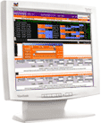  ARE YOU AN INVESTOR?  The Classic Account enables you to trade online through our website, and gives you our research content.   | 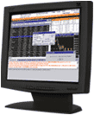  ARE YOU AN ACTIVE TRADER?  SPEEDTRADE is a  next-generation online trading product that brings the power of your broker's terminal to your PC...  
3.1 Classic Account :--

The CLASSIC ACCOUNT is a Sharekhan online trading account, through which you can buy and sell shares through our website www.sharekhan.com in an instant.
Along with enabling access for you to trade online, the CLASSIC ACCOUNT also gives you our Dial-n-Trade service. With this service, all you have to do is dial 1-600-22-7050 to buy and sell shares using your phone.

9 Features of the CLASSIC ACCOUNT
that enable you to invest effortlessly

- Online trading account for investing in Equities and Derivatives via sharekhan.com
- Integration of: Online trading + Bank + Demat account

- Instant cash transfer facility against purchase & sale of shares
- Reasonable transaction charges

- Instant order and trade confirmation by e-mail
- Streaming quotes

- Personalized market watch
- Single screen interface for cash, derivatives and more

- Provision to enter price trigger and view the same online in market watch

3.2 SPEED TRADE ACCOUNT

SPEEDTRADE is an internet-based software application, that enables you to buy and sell shares in an instant.
It’s ideal for active traders and jobbers who transact frequently during day's trading session to capitalize on intra-day price movements.
Speed Trade provides all the features of Classic, with the added functionality of trading in derivatives from the same single-screen software interface.
7 Features of Speed trade
that enable you to trade effortlessly
- Instant order Execution & Confirmation
- Single screen trading terminal
- Real-time streaming quotes, tic-by-tic charts
- Market summary (most traded scrip, highest value)
- Hot keys similar to a brokers terminal
- Alerts and reminders
Back-up facility to place trades on Direct Phone lines
Our Dial-n-Trade service gives you the convenience of buying and selling shares over the phone by calling our dedicated phone lines at 1-600-22-7050.
Click here for more information…
DIAL-N -TRADE now comes as a part of the Sharekhan Classic Account, an exclusive service for trading shares from your telephone.
Just dial 1-600-22-7050*, enter your TPIN number, and you will be directed to a tiebreaker who will buy or sell shares for you.
7 Features of DIAL-N -TRADE
that make the stock market easier to access
- Dedicated Toll-Free number for order placements.
- Automatic fund transfer with phone banking**
- Simple and secure IVR based system for authentication
- No waiting time. Enter TPIN to be transferred to our teleprocess.
- Trusted, professional advice of our tele brokers
- After-hours order placement facility between 9.30 a.m. & 9.45 a.m. ***

- Reliable services wherever you are.
* Mobile users dial 022-1-600-22-7050
** Only for Citibank customers. More banks to be added soon
*** Timing to be extended soon
3.3 Investing advices :--

 | 
 | 

  "Value line" | 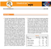  "Investor's Eye" | 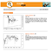  "Eagle Eye"
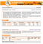  "Trader's Corner" | 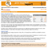  "Pre-Market Report" | 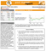  "Post-Market Report"

4 .Different competitors

The major players in online trading

• ShareKhan.com

• 5paisa.com

• KotakStreet.com

• IndiaBulls.com

• ICICIDirect.com

• HDFCsec.com

4.1 Sharekhan

Company Background

• Share khan is the retail broking arm of SSKI Securities Pvt Ltd. SSKI owns 56% in Sharekhan, balance ownership is HSBC, First Carlyle, and Intel Pacific
• Into broking since 80 years
• Focused on providing equity solutions to every segment
• Largest ground network of 210 Branded Share shops in 90 Cities

Online Account Types

•Classic Account / Applet: Investor in equities

•Speed Trade: Trader in equities & derivatives

Pricing for Retail Customers

Speed Trade

•Account Opening: Rs 1000 (Refundable against brokerage in Month + 1)
•Demat 1st Yr : Incl in Account Opening

•Initial Margin: NIL

•Min Margin Retainable: NIL

•Brokerage:
Trading 0.10% each side + All Taxes
Delivery 0.50% each side + All Taxes
(Negotiable based on volume)

•Account Access Charges
Monthly Rs 500, adjustable qtrly against brokerage of Rs 9000/- for qtr

No access charges for gold customers (Above 1 lac brokerage p.a)

Classic A/C

Account opening: 750 (lifetime)

Demat 1st year: free a/c opening

Initial margin: NIL

Minimum margin: NIL

Brokerage:
Trading 0.10% each side + All Taxes
Delivery 0.50% each side + All Taxes
(Negotiable based on volume



  - 5paisa

Company Background

Indiainfoline was founded in 1995 and was positioned as a research firm
In 2000 e-broking was started under the brand name of 5 paisa.com.
Apart from offering online trading in stock market the company offers
Mutual funds online.

It also acts as a distributor of various financial services i.e. GOI securities,
Company Fixed Deposits, Insurance.
Limited ground network, present in 20 Cities
Online Account Types
•Investor Terminal: Investors / Students
•Trader Terminal: Day Traders / HNI’s

PRICING FOR RETAIL CLIENTS

Investor Terminal

•Account Opening: Rs 500

•Demat 1st Yr: Rs 250

•Initial Margin: Rs 2500(Compulsory)

•Min Margin Retainable: Rs 1000

•Brokerage:

Trading 0.10% each side + ST

Delivery 0.50% each side + ST

PRICING FOR HNI CLIENTS

Trader Terminal

•Account Opening: Rs 500

•Demat 1st Yr: Rs 250

•Initial Margin: Rs 5000(Compulsory)

•Min Margin Retainable: Rs 1000

•Brokerage:

Trading 0.10% each side + ST

Delivery 0.50% each side + ST

(Negotiable to 0.05% each side & 0.25%)

•Account Access Charges
Monthly Rs 800, adjustable against Brokerage

Yearly Rs 8000, adjustable against brokerage

Deal Clinchers v/s 5 Paisa

•Company Background

Not having a very positive image, relatively new in the broking arena, limited network

•Downtime

Recent past 5 paisa Trader Terminal (T.T) is experiencing high frequency downtime between 3 – 3:30 p.m due to server load (as their T.T is feature heavy compared to Speedtrade charting)

•Manual Accounting

The 5 paisa accounting system is manual, Online fund transfer through bank is not credited instantly.
Limit is provided EOD for shares sold from DP, or call
Similarly limit released for shares sold under BTST is manual
Delay in receiving pay-out of clear funds from trading to Bank Account.

•Min Account Balance

Concept of Min Rs 1,000 to be maintained in form of cash / securities to keep account active. This can be withdrawn only on closure of account.



Kotakstreet

Company Background

Kotakstreet is the retail arm of kotak securities. Kotak Securities
limited is a joint venture between Kotak Mahindra Bank and
Goldman Sachs

Online Account Types

•Twin Advantage / Green Channel: 2 DP’s, Limit against shares
•Free Way: Flat Rs 999 Cover Charge p.m, 0.03% per transaction
•High Trader: 6 Times Exposure Cash & Derivatives, Auto sq off 2:55
•Cash Expressway: Spot payment, additional 0.5% charges

For Kotak Fast Lane / Keat Lite / Keat Desktop are trading interfaces.
Keat Desktop with advanced tools comes at a charge of Rs 500 p.m,
Non refundable

PRICING OF KOTAK

•Account Opening: Rs 500

•Demat: Rs 22.5 p.m

•Initial Margin: Rs 5000(Compulsory)

•Min Margin Retainable: Rs 1000

•Brokerage Slab wise: Higher the volume, lower the brokerage. Even older customers (on 0.25% & 0.40%) have been moved to the slab wise structure wef 1/4/2004

Slab structure of Kotak

Delivery Vol p m Brokerage *

< 1 lakhs 0.65%
1 lakhs - 5 lakhs 0.60% Square Vol off p m Brokerage **

< 10 lakhs 0.10% Both Sides

10lakhs - 25 lakhs 0.08% Both Sides

25lakhs – 2 Cr 0.06% Both Sides

2 Cr - 5 Cr 0.05% Both Sides

> 5 Cr 0.04% Both Sides

Brokerage is inclusive of All Taxes

** Min Brokerage of Rs 0.01 per share

Derivatives Vol off p m Brokerage

< 2 Cr 0.07% Both Sides

2 Cr - 5.5 Cr 0.05% Both Sides

5.5 Cr - 10 Cr 0.04% Both Sides

> 10 Cr 0.03% Both Sides

Brokerage is inclusive of All Taxes

5 lakhs -10 lakhs 0.50%

10 lakhs -20 lakhs 0.40%

20 lakhs -60 lakhs 0.30%

60 lakhs – 2 Cr 0.25%

>2 Cr 0.20%

DP Charges Extra

Brokerage is inclusive of All Taxes

* Min Brokerage of Rs 0.05 per share

Deal Clinchers v/s Kotakstreet

•Rigid Account Opening Terms

No Flexibility of A/c opening charges (Rs 500) + Compulsory margin Rs 5000/-

Account opening free with Rs 10,000 Margin OR competitor Contract Note.

•No Customization of commercial Terms

No Flexibility in Leverage – Dependent on Type of Account (4 to 6 times only)

No flexibility in Brokerage, driven by slab structure

•Many Other Charges

Rs 22.5 p.m towards DP AMC charges
DP incoming charges extra, 0.02%
Rs 1,000 as retainable Margin to keep account active
Rs 25 per call after 20 calls for the month

•Restricted Access to Terminal Like product

KEAT Desktop restricted distribution on payment of Rs 500, Non refundable



INDIABULLS

Company Background

India Bulls is a retail financial services company present in 70 locations
Covering 62 cities. It offers a full range of financial services and
Products ranging from Equities to Insurance. 450 + Relationship
Managers who act as personal financial advisors

Online Account Type

•Signature Account: Plain Vanilla Account with focus on Equity Analysis. The equity analysis is a paid service even for A/c holders

•Power India bulls: Account with sophisticated trading tools, low commissions and priority access to R.M

Pricing of IB Accounts

Signature Account

•Account Opening: Rs 250

•Demat: Rs 200 if POA is signed, No AMC for this DP

•Initial Margin: NIL

•Brokerage: Negotiable

Power India Bulls

•Account Opening: Rs 750

•Demat: Rs 200 if POA is signed, No AMC for this DP

•Initial Margin: NIL

•Brokerage: Negotiable

PAID Research

SCHEME FACILITY

WebBased-1-Month-500: View & Print on website

WebBased-1-Year-6000 View & Print on website

PrintReport-1-Month-750: View & Print on website + 10

Reports Delivered

PrintReport-1-Year-9000: View & Print on website + 10 Reports Delivered

Deal Clinchers v/s India Bulls

•POA for Clients DMAT

•Paid Research Services

Access to an research even for an IB trading account holder is charged a min of Rs 500 a month

•Margin funding hoax

The interest on funding starts on leveraged delivery trades from T+1 day itself @21% p.a, on a daily basis

•The role of Relationship Manager

Each RM is looked upon as a revenue generator and he gets a % on business generated from client. This can lead to over leveraged (Interest) & high frequency(Brokerage) trading, which may not be in the best interest of the client.



ICICIDirect

Company Background

ICICI Web Trade Limited (IWTL) maintains ICICIdirect.com. IWTL is an
Affiliate of ICICI Bank Limited and the Website is owned by ICICI Bank
Limited

Account Types

•ICICI Direct e-invest Account: Plain Vanilla Account with focus on 3 in 1 advantage. Differentiated in services within the account

1. Cash on spot

2. MarginPlus

Premium trading interface of ICICIDirect Link is given to DBC partners and HNI’s

•Account Opening: Rs 750

•Schemes: For short periods Rs 750 is refundable against brokerage

Generated in a qtr. These schemes are introduced 3-4 times a year.

•Demat: NIL, 1st year charges included in Account Opening Plus a facility to open additional 4 DP’s without 1st yr AMC

•Initial Margin: Nil

•Brokerage: All brokerage is inclusive of stamp duty and exclusive of other taxes.

Delivery Vol per qtr Brokerage * Square Vol off p m Brokerage **

< 10 lakhs 0.75%

10 lakhs - 25 lakhs 0.70%

25 lakhs -50 lakhs 0.55%

50 lakhs – 1 Cr 0.45%

1 Cr – 2 Cr 0.35%

2 Cr – 5 Cr 0.30%

> 5 Cr 0.25%

Deal Clinchers v/s ICICIDirect

•Poor online Interface

Slow website interface with no real-time quotes creates dissatisfaction among high frequency traders

•Margin trading restriction

The margin trading system is available up to 2:45 p.m, with outstanding net positions under margin segment automatically squared off at any time between 2:45 – 3:30 p.m. Thus no control of square off price.

•Morning Trades Issue

Being one of the websites with largest no of after hour orders which are pushed 1st thing in the morning, creates a choking of orders to the exchange, causes delay of confirmations for new order placed during the early morning trades
•Restriction of BTST

The sale of shares purchased is restricted to T+1 day and is not permitted on T+2 Day.

•No leverage for Delivery trades

Delivery is restricted to the total money allocated into the trading account.

•No flexibility on leverage on Intra-day trades
The leverage of 4 times is available for intra- day trades.

•Restriction of Bank Account
The choice of bank is restricted to ICICI Bank.

•Higher Brokerage rates with slabs

The delivery brokerage is pegged at 0.75% and trading at 0.10% each side, this makes is very unviable for customers dealing in large volumes. Although progressively the delivery and trading brokerage reduce as volumes go up.

hdfcsecurities.com

What you need, when you need it

HDFC Securities

Company Background

HDFC Securities Ltd, is promoted by the HDFC Bank, HDFC and Chase
Capital Partners and their associates. Pioneers in setting
Up Dial-a-share services with the largest team of Tele-brokers

Online Account Type

HDFC Online Trading A/c: Plain Vanilla Account with focus on 3 in 1 advantage

Pricing of HDFC Account

•Account Opening: Rs 750

•Demat: NIL, 1st year charges included in Account Opening

•Initial Margin: Rs 5000/- for non HDFC Bank customers ( AQB)

•Brokerage:

Trading 0.15%* each side + ST

Delivery 0.50%** each side + ST

* Rs 25 Min Brokerage per transaction
** Rs 8 Min Brokerage per transaction

Deal Clinchers v/s HDFC Securities

•Poor online Interface

Apart from having no product to cater to Day-Traders, the hdfcsec.com website is plagued with downtime. The same is currently
Being revamped.

•Lack of focus on Broking

The core business of HDFC is Housing Finance and that of HDFC Bank is banking. Broking as a business is a small part of the portfolio of
Financial services and hence the commitment to resources is limited.

•No Leverage
No leverage is available to clients even for Intra-Day trades, effectively all clients are on cash and carry system.

•No flexibility in commercial terms
The delivery brokerage is pegged at 0.5% and trading at 0.15% each side, this makes it unviable for customers dealing in large volumes.

5. Requirement for opening online account

Sharekhan Depository Services

Dematerialization and trading in the demat mode is the safer and faster alternative to the physical existence of securities. Demat as a parallel solution offers freedom from delays, thefts, forgeries, settlement risks and paper work. This system works through depository participants (DPs) who offer demat services and the securities are held in the electronic form for the investor directly by the Depository.
Sharekhan Depository Services offers dematerialization services to individual and corporate investors. We have a team of professionals and the latest technological expertise dedicated exclusively to our demat department, apart from a national network of franchisee, making our services quick, convenient and efficient.
At Sharekhan, our commitment is to provide a complete demat solution which is simple, safe and secure.

Opening a DP account with Sharekhan

- You can open a Depository Participant (DP) account, either through a Sharekhan branch or through a Sharekhan Franchisee center.

- There is no fee for opening DP accounts with Sharekhan. However a nominal deposit (refundable) is charged towards services which will be adjusted against all future billings.

5.1 Documents required to opening of demat account:--

Requirement for opening Demat a\c:

All investors have to submit their proof of identity and proof of address along with the prescribed account opening form.

- Proof of identity: You can submit a copy of Passport, Voters ID card, Driving license or PAN card with photograph.
- Proof of address: You can submit a copy of Passport, Voters ID card, Driving license, PAN card with photograph, Ration card or Bank passbook as proof of address. You must remember to take original documents to the DP for verification.

- Passport-size photograph.
The above are mandatory requirements as per Securities and Exchange Board of India.

Dematerialization with Sharekhan

Dematerialization is the process by which a client can get physical certificates converted into electronic balances maintained in his account with the DP.
Features:

- Holdings in only those securities that are admitted for dematerialization by National Securities Depository Ltd (NSDL) can be dematerialized.
- Structure of holding in the securities should match with the account structure of the depository account. Now shares in different order of names can also be dematted.

Example:
If the shares are in the name of X and Y, the same cannot be dematerialized into the account of either X or Y alone. However if the shares are in the name of X first and Y second, and the account is in the name of Y first and X second, then these shares can be dematerialized in this account.

Only those holdings that are registered in the name of the account holder can be dematerialized. Physical shares which have not been transferred and are still there with a transfer deed cannot be dematted. Only a few companies have been given the permission to offer Transfer-cum-Demat. The list of these companies can be viewed here.

Rematerialization

Rematerialization is the process by which a client can get his electronic holdings converted into physical certificates. The client has to submit the rematerialisation request to the DP with whom he has an account along with a Remat request form. The physical shares will be posted by the company directly to the clients.

Trades

For all sales made by clients, the shares will have to be given to the broker, so that the Pay In can be made by the broker to the stock exchange concerned. For that it's essential that the shares be transferred to the account of the broker well before the deadline date.
You must confirm with your broker the settlement date and settlement number and then submit your instructions to your DP. Also it's important to give the instructions to your DP as early as possible.
Pledge

Pledge enables you to obtain loans against your dematerialized shares. So you get liquidity without having to sell your shares.

A highly simplified procedure may be availed of for pledging of securities in the electronic mode. The pledged securities continue to be reflected in the DP account of the clients (pledgor) but the concerned securities are "blocked" and cannot be used for any transactions. As and when the pledge is to be removed, based on confirmations received from both the pledgor and the pledge, the blocked securities will be released to "Free Balance" of the account holder.
A very big advantage of using pledges in the electronic mode is that the securities continue to be in your account and therefore all benefits--viz Dividend, Bonus and Rights--accrue to the holder, i.e. you and not the bank (pledge).

Corporate Benefits

Corporate benefits are benefits given by a company to its investors. These may be either monetary benefits like dividend, interest etc or non-monetary benefits like bonus, rights etc. NSDL facilitates distribution of corporate benefits. It's important to mention your correct MICR No and attach copy of the cheque leaf with your account opening form. NSDL is planning to distribute all cash corporate benefits to bank accounts directly.
5.2 Computer Hardware and Software requirement

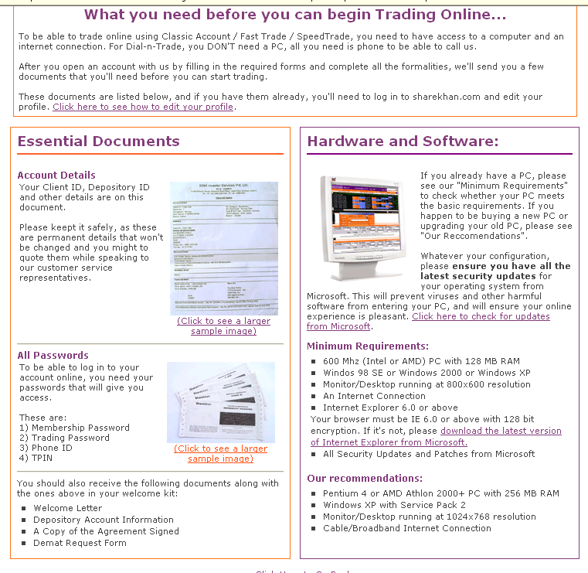

5.3 Different charges taken by Sharekhan for its services.

"Schedule A" effective from 1st Jan, 2004
Charge Head | SSKI Investor | Other Investor | High Trader | Remarks
Account Opening | NIL | NIL | NIL
Account Closing | NIL | NIL | NIL
Annual Maintenance Charges | Rs 500 p.a | Rs 300 p.a | Rs 900 p.a | Payable in advance.
Dematerialization | Rs 3 per cert. | Rs 3 per cessrt. | Rs 3 per cert. | Minimum Rs 15
Rematerialization | Rs 15 per cert. | Rs 15 per cert. | Rs 15 per cert.
 | If Broking Through SSKI | If Broking Not Through SSKI
Purchases | NIL : ZERO | 0.02% / Min.Rs .8 | NIL
Sales | NIL : ZERO | 0.02% /  Min.Rs 18 | Rs.8 +0.01%
Brokerage | Minimum Rs 10 per Scrip. | NA. | NA
Custody | Re 1 per ISIN/month | Re 1 per ISIN/month | Re 1 per ISIN/month | If client does not have any security balance in his account still he will be charged assuming 1 scrip in his account *
Pledge Creation | 0.02% | 0.02% | 0.02% | Minimum Rs 50
Freeze \ De-freeze | Rs 25/- per request | Rs 25/- per request | Rs 25/- per request
Deposit | Rs 500/- | Rs 500/- | Rs 1500/- | Adjustable agst.all dues

6.ANALYSIS

6.1 Learning about dematerialization

6.1.1 How to convert your security to demat form:--

Process of conversion of securities into the demat form
Securities specified as being eligible for dematerialization by the depository in its bye laws and as under the SEBI (Depositories and Participants) Regulations, 1996 (the Regulations) can be converted or issued in a dematerialized form. The process of conversion of securities into a dematerialized form or the issuance of the same in a dematerialized form can be explained thus:
1. Firstly, the issuer company, whose securities are eligible for dematerialization, has to enter into an agreement with a depository for dematerialization of securities already issued, or proposed to be issued to the public or existing shareholders .

2. The investor is given an option to hold the securities in a dematerialized form and it is his prerogative to exercise the option to hold the securities in that manner.

3.The depository enters into an agreement with the participants who are the agents of the depository and co-functionaries in the process of dematerialization of securities.

4. Any person can then enter into an agreement, through the participant, with the depository for availing the services provided by the depository.

5.Upon the entering into such agreement with the depository, the person has to surrender the certificate pertaining to the securities sought to be dematerialized to the issuer. This surrender is affected in the following manner
(i) The person (beneficial owner) who has entered into an agreement with the participant for dematerialization of the securities has to inform the participant about the details of the certificate of such securities.
(ii) The beneficial owner has to then surrender the said certificate to the participant.
(iii) The participant informs the depository about the particulars of the securities to be dematerialized and the agreement entered into between him and the beneficial owner.
(iv) The participant then transfers the certificate pertaining to the said securities to the issuer along with the details and particulars of the securities.
(v) These certificates are mutilated upon receipt by the issuer and substituted in the records against the name of the depository, who is the registered owner of the said securities. A certificate to this effect is sent to the depository and all stock exchanges where the security is listed.
(vi) Subsequent to this, the depository enters the name of the person who has surrendered the certificate of security as the beneficial owner of the dematerialized securities.
(vii) The depository also enters the name of the participant through whom the process has been carried out and sends an intimation of the same to the said participant.
6. Once the aforesaid process of dematerialization is carried out, the depository has the responsibility to maintain all the records pertaining to the securities that have been dematerialized.

Benefits of Depository System:--

In the depository system, the ownership and transfer of securities takes place by means of electronic book entries. At the outset, this system rids the capital market of the dangers related to handling of paper. NSDL provides numerous direct and indirect benefits, like:
- Elimination of bad deliveries

In the depository environment, once holdings of an investor are dematerialized, the question of bad delivery does not arise i.e. they cannot be held "under objection". In the physical environment, buyer was required to take the risk of transfer and face uncertainty of the quality of assets purchased. In a depository environment good money certainly begets good quality of assets.

- Elimination of all risks associated with physical certificates

Dealing in physical securities have associated security risks of theft of stocks, mutilation of certificates, loss of certificates during movements through and from the registrars, thus exposing the investor to the cost of obtaining duplicate certificates and advertisements, etc. This problem does not arise in the depository environment.
- No stamp duty

for transfer of any kind of securities in the depository. This waiver extends to equity shares, debt instruments and units of mutual funds.

- Immediate transfer and registration of securities

In the depository environment, once the securities are credited to the investors account on pay out, he becomes the legal owner of the securities. There is no further need to send it to the company's registrar for registration. Having purchased securities in the physical environment, the investor has to send it to the company's registrar so that the change of ownership can be registered. This process usually takes around three to four months and is rarely completed within the statutory framework of two months thus exposing the investor to opportunity cost of delay in transfer and to risk of loss in transit. To overcome this, the normally accepted practice is to hold the securities in street names i.e. not to register the change of ownership. However, if the investors miss a book closure the securities are not good for delivery and the investor would also stand to loose his corporate entitlements.
- Faster settlement cycle

The exclusive demat segments follow rolling settlement cycle of T+2 i.e. the settlement of trades will be on the 2nd working day from the trade day. This will enable faster turnover of stock and more liquidity with the investor.

- Faster disbursement of non cash corporate benefits like rights, bonus, etc.
NSDL provides for direct credit of non cash corporate entitlements to an investors account, thereby ensuring faster disbursement and avoiding risk of loss of certificates in transit.

- Reduction in brokerage by many brokers for trading in dematerialized securities

Brokers provide this benefit to investors as dealing in dematerialized securities reduces their back office cost of handling paper and also eliminates the risk of being the introducing broker.

- Reduction in handling of huge volumes of paper

- Periodic status reports to investors on their holdings and transactions, leading to better controls.
- Elimination of problems related to change of address of investor, transmission, etc

In case of change of address or transmission of demat shares, investors are saved from undergoing the entire change procedure with each company or registrar. Investors have to only inform their DP with all relevant documents and the required changes are effected in the database of all the companies, where the investor is a registered holder of securities.
- Elimination of problems related to selling securities on behalf of a minor

A natural guardian is not required to take court approval for selling demat securities on behalf of a minor.

- Ease in portfolio monitoring

Since statement of account gives a consolidated position of investments in all instruments.

6.1.3 Disadvantages of Dematerialization
The disadvantages of dematerialization of securities can be summarized as follows:
A. Trading in securities may become uncontrolled in case of dematerialized securities.
B. It is incumbent upon the capital market regulator to keep a close watch on the trading in dematerialized securities and see to it that trading does not act as a detriment to investors. The role of key market players in case of dematerialized securities, such as stock-brokers, needs to be supervised as they have the capability of manipulating the market.
C. Multiple regulatory frameworks have to be confirmed to, including the Depositories Act, Regulations and the various Bye Laws of various depositories. Additionally, agreements are entered at various levels in the process of dematerialization. These may cause anxiety to the investor desirous of simplicity in terms of transactions in dematerialized securities.
However, the advantages of dematerialization outweigh its disadvantages and the changes ushered in by SEBI and the Central Government in terms of compulsory dematerialization of securities are important for developing the securities market to a degree of advancement. Freely traded securities are an essential component of such an advanced market and dematerialization addresses such issues and is a step towards the advancement of the market.
6.1.4 Depository System (working model)

NSDL carries out its activities through various functionaries called business partners who include Depository Participants (DPs), Issuing companies and their Registrars and Share Transfer Agents, Clearing corporations/ Clearing Houses of Stock Exchanges. NSDL is electronically linked to each of these business partners via a satellite link through Very Small Aperture Terminals (VSATs) or through Leased land lines. The entire integrated system (including the electronic links and the software at NSDL and each business partner's end) is called the "NEST" [National Electronic Settlement & Transfer] system.

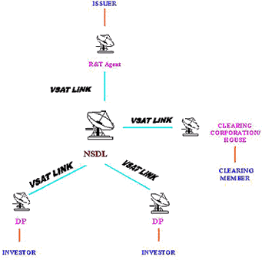
6.1.5 Growth of dematerilization
Data Related to dematerialization 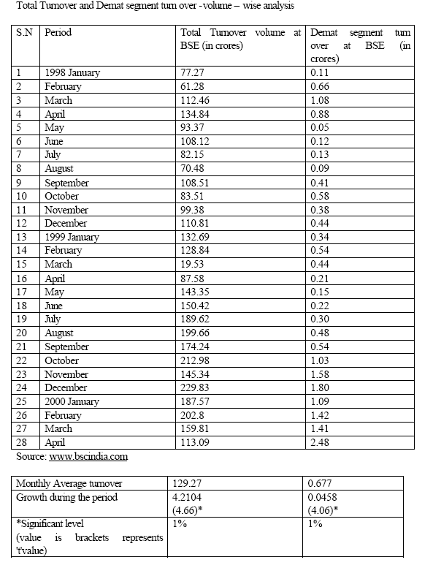
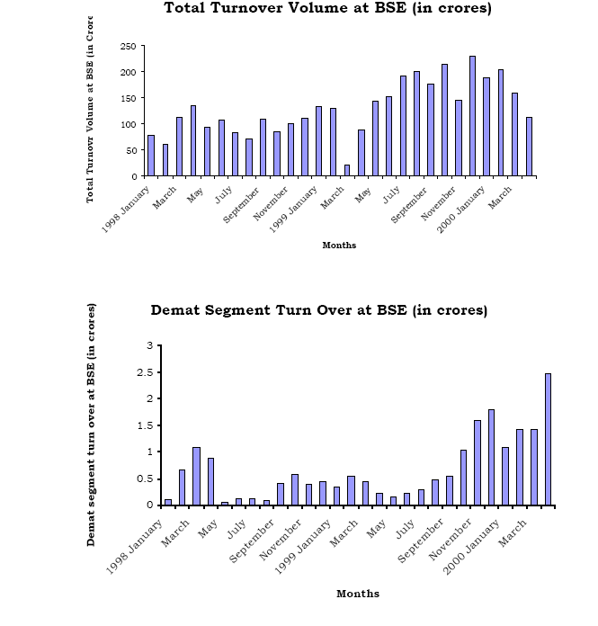
Explanation of diagram:
The monthly average turn over was 129.27 corers shares in the total turn over segment and 0.677 corers shares was in demat segment. This clearly reveals that the growth in the dematerialization process was not keeping pace with the growth in the total turn over of shares in the Indian capital market (Stock Exchange). This shows that in spite of popularity of the dematerialization process or electronic buying, selling and possessing of shares are not popular.
The popularity of buying and selling of shares through electronic
mode/dematerialization process can be studied through the volume of the shares transferred through electronic mode and hence, an attempt is also made through delivery wise analysis of the total turn over shares. Here, analysis has also been conducted on the growth of the total volume of delivery of shares in the BSE and delivery of the same through electronic/demat mode. Table & Graph shows that Total Volume Delivery of Shares in BSE and Demat Segment

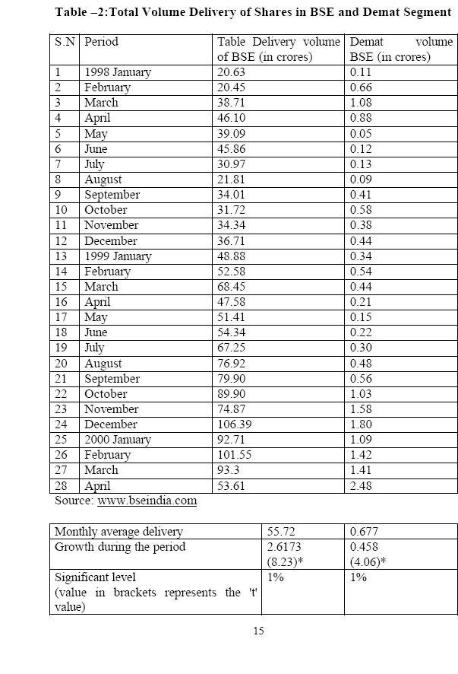
Explanation of Diagram
The analysis of the table reveals that the monthly average delivery in the BSE over the period from January 1998 to April 2000, was 55.72 corers shares and the same in the demat segment mode was 0.677 corers shares revealing a poor share through the new mode.
The total deliveries represent the Delivery of A-Group, B1-Group, B2 Group and demat Group securities at BSE. The delivery of demat segments represents the exclusive demat transaction.
However when an attempt was made to find out the annual growth of the delivery through both modes it revealed that delivery is the Indian Capital market was growing on an average at a rate of 2.6173 corers share and delivery of share through the dematerialized segment was on an average of 0.458 corers shares per month. When these trends in the growth were tested with the students’t’ test, both segments growth wore found significant at/ percent level.
This leads to the conclusion that in the volume wise analyze/comparison conducted both for the total turn over and turnover through dematerialized process and the total delivery in the BSE and delivery through the demat mode have not grown as the generally know physical/paper mode have grown. This may be due to lack of information and also short direction after he inception of the scheme.
The volume analysis conducted earlier may represent the number of shares dealt in the stock exchange, but there one certain, shares, which are high in market value and certain other company’s shares are low in value therefore the value of the shares dealt in the dematerialization becomes essential one. Table & Graph shows that total turnover & Exclusive demat segment turnover at BSE (Value-Wise analysis)
s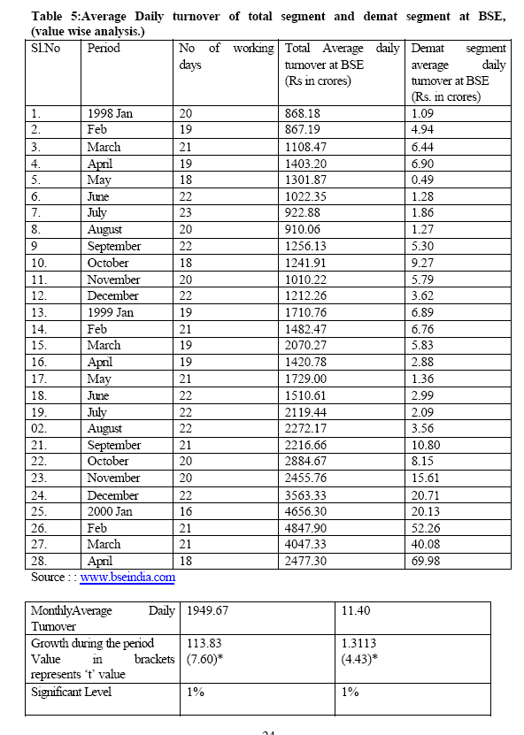
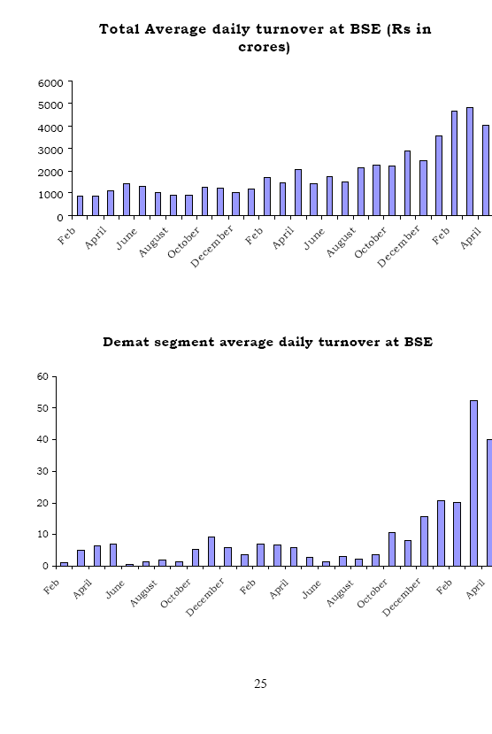

Analysis:

The number of trading days in a month has been ranging between 16 days (January 2000) and 23 days (July 1998). From the Table IV - 5 it can be observed that the average daily turnover in a month have been at a rate of Rs. 13.83 corers per month in the total segment and in the demat segment it was on an average Rs. 1.3113 corers per month.
When verify the result, the student’t’ statistics have showed that the growth in both the segments are significant are 1 percent level.
While analyzed the average daily turnover in a month it was found that Rs. 1949.67 corers in the total segment. At the same time in the demat segment the monthly average daily turnover was Rs. 11.40 corers during the trading days.
From the above result it can be concluded that the average daily turnover was growing at a minimum rate in rate in demat segment, when compare to total segment. This may be due to the infancy stage of demat segment. But how ever in the latest periods (i.e. from January 2000) it is growing at a fast rate.

6.2 Analysis on future of online trading

Broker-wise Business Done
(From July 1999 to June 2000)
Brokers* | Business  Done | Brokerage Paid  (Rs. in Lakh) | Broker wise contracts outstanding for more than 60 days | % to Total
UTI Securities & Exchange Ltd. | 58095249148.70 | 364.8050 | Nil | 22.8492
AJCON Capital Markets Ltd. | 5791667584.90 | 29.7400 | Nil | 2.2779
KJMC Capital Market Services Ltd. | 5403176981.62 | 27.8800 | Nil | 2.1251
PNR Securities Ltd. | 5207165284.77 | 36.9500 | Nil | 2.0480
DSP Merrill Lynch Ltd. | 5161988027.92 | 45.0300 | Nil | 2.0302
S S Kantilal Ishwarlal Securities | 4919280820.11 | 119.9500 | Nil | 1.9348
IDBI Capital Market Services | 4887066448.82 | 119.1550 | Nil | 1.9221
Mukesh Babu Securities Ltd. | 4074343429.84 | 72.1000 | Nil | 1.6025
ICICI | 3807355200.00 | 0.0000 | Nil | 1.4975
Bonanza Portfolio Ltd. | 3566594657.13 | 21.4200 | Nil | 1.4028
Dolat Capital Market Ltd. | 3295896951.91 | 89.2250 | Nil | 1.2963
ICICI Brokerage Services Ltd. | 3263458260.80 | 87.1400 | Nil | 1.2835
Roongta Capital Markets Pvt. Ltd. | 2544422898.95 | 66.6400 | Nil | 1.0007
J M Morgan Satiny Securities | 2501907205.83 | 61.3900 | Nil | 0.9840
ICICI Sec. & Fin. Co. Ltd. | 2416875564.40 | 0.0000 | Nil | 0.9506
Bhagirath Merchant Stock Brok. | 2382992171.44 | 60.8500 | Nil | 0.9372
Mata Securities India Pvt. Ltd. | 2296753616.21 | 21.8550 | Nil | 0.9033
Dhanki Securities Pvt. Ltd. | 2275933637.13 | 52.7800 | Nil | 0.8951
ABN Amro Asia Equities (I) Ltd. | 2141347460.32 | 55.4500 | Nil | 0.8422
Deutsche Bank | 2097139250.00 | 0.0000 | Nil | 0.8248

From the above chart we can easily see that share is very spread.
Ifs and Buts of Indian online share trading
You have some money to dabble with. Trading shares on BSE/NSE has always been your dream. When will you ever find the time? And besides, the hassle of finding a broker is not easy.
Realizing there is untapped market of investors who want to be able to execute their own trades when it suits them, brokers have taken their trading rooms to the Internet. Known as online brokers, they allow you to buy and sell shares via Internet.
There are 2 types of online trading service: discount brokers and full service online broker. Discount online brokers allow you to trade via Internet at reduced rates. Some provide quality research, other don’t. Full service online brokerage is linked to existing brokerages. These brokers allow their clients to place online orders with the option of talking/ chatting to brokers if advice is needed. Brokerage rates here are higher. 5Paisa.com, ICICIDirect.com, IndiaBulls.com, Sharekhan.com, Geojit securities.com, HDFCsec.com, Tatatdw.com, Kotakstreet.com are some of the online broking sites in India.
There are currently close to 50 online brokerages in India with ICICIDirect, Home Trade, KotakStreet, Sharekhan, Motilal Oswal, India Bulls and 5Paisa being some major players. However, due to limited volumes, no online brokerage is currently making money and a shakeout is imminent in the near future. The going is expected to get tougher with the advent of capital account convertibility. Players such as TD Waterhouse have already entered the Indian market, while others such as Schwab are expected shortly. On an average, Rs 40 corer per day (Rs 1,000 corer per month) is likely to be the threshold breakeven for online brokerages. However Hiren Gada, senior VP, Home Trade is not unduly perturbed. “We at Home Trade believe there is scope for multiple players as the entire segment is in a growth stage. Hence, notwithstanding the current sentiment in the market, potential for online trading is still immense in India.” Says Manish Shukla, VP, Internet broking, Motilal Oswal, “By mid-2002 we should be able to see substantial volumes in the domestic market for Internet-based stock trading. In the next 18 months a lot of players will get in, the market will change form and shape, and many people will get out. You will have the survivors and stable volumes.”
Q.1. which brand gives the more customer value?

Customer value analysis.

Customer Value = Customer Benefits – Customer Costs

Customer costs = Price + Other Costs (Acquisition costs, Usage costs, Maintenance costs, Ownership costs, Disposal costs)

Q.2.How customer rating the brands.

Customer Product Technical Selling
Awareness Quality Availability Assistance Staff

ICICI

HDFC

INDIA BULLS

KOTAK SEC

5PAISE

FORTIES

SSKI

E =excellent, G = good, F = fair, P = poor

 | ICICI DIRECT | KOTAK SEC. | INDIA BULLS | HDFC SEC. | 5PAISE | FORTIS | UTI | SHAREKHAN
accounting charges | Rs 750 | Rs 700 | Rs 700 | Rs 750 | Rs 425 | Rs 200 | Rs 600 | Rs 750
brokerage | 0.55% | 0.50% | 0.50% | 0.50% | 0.50% | 0.50% | 0.50% | 0.50%
service tax | 10.20% | 10.20% | 10.20% | 10.20% | 10.20% | 10.20% | 10.20% | 10.20%
STT | 0.01% | 0.01% | 0.01% | 0.01% | 0.01% | 0.01% | 0.01% | 0.01%

CASH SEGMENT | ICICI DIRECT
delivery trade | 0.08% | N.A | 0.08% | N.A | 0.50% | N.A | N.A | N.A
non.delivery trade | 0.15% | N.A | 0.15% | N.A | 0.10% | N.A | N.A | N.A
min. order | Rs.500 | Rs.500 | Rs.500 | Rs.500 | N.A | N.A | Rs.500 | N.A
min. brokerage | Rs.25 | N.A | N.A | N.A | N.A | N.A | N.A | 10 paisa
brokerage | 1% | N.A | N.A | 0.05% | 0.05% | N.A | N.A | N.A
jobbing | N.A | 3.10 p.m | 3.15 p.m | N.A | 2.40 p.m | N.A | N.A | 3.15 p.m

SPOT SEGMENT
min. trade | Rs 500 | Rs 500 | Rs 500 | Rs 500 | N.A | Rs 500 | N.A | N.A
max. amount | RS. 10 lakh | no limit | no limit | no limit | N.A | N.A | N.A | N.A
brokerage | 0.10% | 0.05% | N.A | 0.05% | 0.25% | N.A | N.A | 0.05%

MARGIN SEGMENT
min. trade | Rs 500 | Rs 500 | Rs 500 | Rs 500 | N.A | N.A | N.A | N.A
min. brokerage | RS 15 | N.A | N.A | Rs 15 | N.A | N.A | N.A | N.A
brokerage | 0.04% | N.A | N.A | 0.05% | N.A | N.A | N.A | 0.05%

DERIVATIVE SEGMENT
service tax | 10.20% | 10.20% | 10.20% | 10.20% | 10.20% | 10.20% | 10.20% | 10.20%
STT | 0.01% | 0.01% | 0.01% | 0.01% | 0.01% | 0.01% | 0.01% | 0.01%
min. balance | Rs 5000 | N.A | N.A | Rs 5000 | Rs 2000 | N.A | N.A | N.A

BANK FEE
min. balance | Rs 5000 | N.A | N.A | Rs 5000 | N.A | N.A | N.A | N.A
penalty | Rs 750 | N.A | N.A | NIL | N.A | N.A | NIL | NIL
accounting charges | NIL | N.A | N.A | NIL | N.A | N.A | N.A | NIL
custody charges | Rs 2.25 | N.A | N.A | N.A | N.A | free | NIL | N.A
transaction- buy | 0.02% | N.A | N.A | NIL | 2.50% | free | NIL | free
- sell | 0.04% | Rs 20 per form | N.A | 0.04% | 2.50% | Rs 20 | 0.04% | free
stamp charges | 0.02% | N.A | N.A | N.A | Rs 420 p. form | Rs 60 p. a/c | N.A | 0.01%

DEMAT ACCOUNT
rejections or fails | Rs 20 | N.A | Rs 20 | NIL | Rs 20 per entry | Rs 30 p.rej | Rs 15 p. cer | N.A
remat charges | Rs 20 | N.A | Rs 15 | N.A | Rs 15 p.cer | SDL+ Rs 25p.cer | min. Rs 50 | N.A
pledge | 0.20% | NO | 0.02% | Rs 10 p.cer | Rs 30p.ins | 0.02% | 0.02% | 0.02%
demat charges | N.A | Rs 360 p.a | N.A | Rs 3 p.cer | Rs 5 p.cer | Rs 1 p.cer | min. Rs 50 | N.A

DEPOSITORY RELATIONSHIP
advance amount | Rs 2500 | Rs 3500-5000 | N.A | Rs 2500 | Rs 2000 | Rs 20-50000 | Rs 500 | N.A
thresh hold amount | Rs 1000 | Rs 1000 | N.A | Rs 1000 | N.A | N.A | N.A | N.A
funding | yes | yes | 21% p.a | yes | N.A | N.A | N.A | yes
IPO | yes | yes | yes | yes | no | no | no | yes
Research Report | N.A | 75% | 80% | N.A | N.A | N.A | N.A | 86%
Exposure | 4 times | 4 times | 6 times | 5-7 times | 6-8 times | N.A | 7 times | 4 times

COMPETITOR STRATEGIES

According to me ICICI DIRECT and INDIA BULLS are the main competitor of the SHAREKHAN and UTI is also in the race.
- Accounting charges of all the banks are close to the figure of Rs. 700-750 and if SHAREKHAN has to win the race in the competition they have to lower down their accounting charges up to Rs. 650. The accounting charges of banks are given below:

ACCOUNTING CHARGES

- BROKERAGE CHARGES: brokerage charges of the entire competitor are similar with the SHAREKHAN i.e. .50% except ICICI that is charging .55%. So the strategy to compete with ICICI is to provide more service with the same brokerage. The chart of brokerage is given below:

3. U.S.P OF SHAREKHAN: - Unique selling purpose of SHAREKHAN is the free transaction of shares. Customers of SHAREKHAN can make transactions anytime, anyhow and without paying any charges that’s why the customers are happy and deal more with the SHAREKHAN. Competitors of SHAREKHAN are charging for every transaction.

Transactions buy:

Transactions sell:

There are only 2 companies who are charging in terms of Rupees and that are KOTAK MAHINDRA who is charging Rs 20 per form and FORTIS who is charging Rs 20 per form.

- RESEARCH REPORT: - SHAREKHAN is the leader under this segment with 86%.

- EXPOSURE: - SHAREKHAN exposure is 4 times and 5 PAISA is the leader here with 6-8 times.

PROBABILITY CHART OF CHANGING THE PRESENT BANK: -

 | ICICI DIRECT | KOTAK SEC. | INDIA BULLS | HDFC SEC. | 5PAISE | FORTIS | UTI | SHAREKHAN
ICICI DIRECT | 65% | 20% | 10% | 22% | 15% | 18% | 17% | 10%
KOTAK SECURITIES | 2% | 35% | ------ | 2% | ------ | 5% | 5% | ------
INDIA BULLS | 15% | 15% | 70% | 25% | 5% | 20% | 15% | 20%
HDFC SEC. | -------- | 2% | ------ | 40% | ------ | 10% | 1% | ------
5PAISE | -------- | 3% | ------ | 2% | 40% | 2% | 2% | 2%
UTI | 5% | 10% | 5% | ----- | 10% | ------ | 45% | 5%
FORTIS | -------- | 5% | 2% | ----- | 5% | 30% | 5% | ------
SHAREKHAN | 13% | 10% | 13% | 9% | 25% | 15% | 10% | 63%

“THE BEST DEFENCE IS GOOD OFFENCE”

SHAREKHAN should select a strategy of POSITION DEFENCE under which

- SHAREKHAN should be focused on customer satisfaction and the product availability and treat their customer as GOD. The best way of competing with the competitor is to make your customer satisfied, which results in the loyalty of your customers for your company.

- SHAREKHAN should continuously do a RESEARCH AND DEVELOPMENT PROGRAMME, which will result in the information about the customers. For that they should appoint R&D depts. Which will continuously do this work?

conclusion

Indian economy has been globalized and the capital market has been linked to the international

Financial market. Foreign individuals and institutional investors have encouraged participating into it. So, there is a need for raising the Indian Capital market in to the international standards in terms of efficiency and transparency. One such measure is the passing out of the Depository Act during the year 1996.
Dematerialization of securities and under this system is one of the major steps aimed at improving and modernizing the capital market and enhancing the levels of investor’s protection measures which aims at eliminating the bad deliveries and forgery of shares and expediting the transfer of shares.
The draw back of the old system and the pool proof measures sought to improve efficiency in transfer and transparency standards prompted to evaluate the functioning of the dematerialization process and to focus on the 8developments of the depository system in the Indian capital market.
The study showed that there is a growth in the shares included in the
Dematerialization process both in terms of volume of shares and value of

8. REFERENCES

- Securities Market (Basic) Module :--NCFM

- Economic Times.

- Training Kit Provided by the Sharekhan.

- Economic times

Websites:

www.indiastat.com

www.sharekhan.com

www.equitymaster.com

www.icicidirect.com

www.sdfcsecurities.com

www.indiabulls.com

www.kotakstreet.com

