A
SUMMER TRAINING REPORT

ON
“WORKING CAPITAL MANAGEMENT”
CONDUCTED AT:


SUBMITTED TO:
GURU GOVIND SINGH INDRAPRASTHA UNIVERSITY
In partial fulfillment of the requirement for the award of the degree of
MASTERS OF BUSINESS ADMINISTRATION

(Session 2009-2011)

UNDER THE SUPERVISION OF: SUBMITTED BY:
Mr. AMIT SHARMA RAJESH CHAURASIA
Faculty (MBA) MBA-3RD SEM.
ROLL NO…10516603909

UNIVERSITY SCHOOL OD MANAGEMENT STUDIES


DECLARATION

I, Rajesh Chaurasia , Roll No. 10516603909 M.B.A. Final year (III semester) of UNIVERSITY SCHOOL OF MANAGEMENT STUDIES KASHMIRI GATE hereby state that the Summer Training Report entitled "WORKING CAPITAL MANAGEMENT OF LUMINOUS”. I submitted of degree of Master of Business Administration. It is an original work done by me and the information provided in the study is authentic to the best of my knowledge and the same has not been submitted to any other institute for the award of any other degree.

DATE:
PLACE: RAJESH CHAURASIA

PREFACE

Practical knowledge is an important suffix to theoretical knowledge. One cannot merely depend upon the theoretical knowledge. Classroom lectures make the fundamental concepts of management clear. They also facilitate the learning of practical things. However to develop healthy managerial and administrative skills for potential managers, it is necessary that they combine their classroom learning with real life project research which plays a significant role in the curriculum of Business Management Courses.
Any science without its practical application or knowledge is considered to be unsystematic. Since management is a developing science, the students of Management courses are required to undergo a project in the final year of the course.
Thus for the fulfillment of the above requirement a project was undertaken by me on the topic “WORKING CAPITAL MANAGEMENT OF LUMINOUS”. The project was a good experience and helped me in widening my knowledge and sharpening management skills.

ACKNOWLEDGEMENT

“Learning is a treasure that will follow its owner everywhere.”

The satisfaction and euphoria that accompany the successful completion of any task would be incomplete without mentioning the people who made it possible, whose consistent guidance and encouragement crowned the efforts with success.
I would consider it my privilege to express my gratitude and respect to MR. RANJEEV KAPOOR for having accorded me the opportunity to learn in their organization.
I cannot forget the contribution of the staff of LUMINOUS POWER TECHNOLOGY LTD. As I troubled them through my queries at every stage of their work and I really appreciate the patience with which they resolved my doubts amidst their busy schedule, I express my sincere thanks to all of them. I also like to thank our placement coordinator who has provided me the opportunity to do my summer training and get engaged with such a supreme organization.
I am also thankful to Mr. Amit Sharma for their constant guidance, co-operation and their valuable time, without their help the project would not have proven meaningful

(RAJESH CHAURASIA)

LIST OF TABLES

4.1 Calculation Of Working Capital
4.2 Comparative Balance Sheet
4.3 Schedule Of Changes In Working Capital
4.4 Working Capital Cycle
4.5 Cash Management Of Luminous
4.6 Inventory Management Of Luminous
4.7 Recievable Management In Luminous
5.1 Calculation Of Liquidity Ratios
5.2 Calculation Of Debt Equity Ratio
5.3 Calculation Of Total Assets To Debt Ratio
5.4 Calculation Of Proprietory Ratio
5.5 Calculation Of Stock Turnover Ratio
5.6 Calculation Of Debtors Turnover Ratio
5.7 Calculation Of Creditor Turnover Ratio
5.8 Calculation Of Working Capital Turnover Ratio
5.9 Gross Profit Ratio
5.10 Net Profit Ratio

LIST OF GRAPHS

4.1 Total Current Assets
4.2 Total Current Liabilities
4.3 Working Capital
4.4 Net Working Capital Conversion Period
4.5 Total Cash And Bank Balance
4.6 Total Inventory
4.7 Total Sundry Debtors
5.1 Current Ratio And Quick Ratio
5.2 Solvency Ratios
5.3 Activity Ratios
5.4 Profitability Ratios

CONTENTS

CERTIFICATE……………………………………………………………………….. i
DECLARATION………………………………………………………………........... ii
PREFACE……………………………………………………………………………. iii
ACKNOWLEGEMENT…………………………………………………………….. iv
LIST OF TABLES……………………………………………………………………. v
LIST OF GRAPHS…………………………………………………………………... vi
CHAPTER: 1. INTRODUCTION………………………………………………..
CHAPTER: 2 OBJECTIVE OF PROJECT…………………………………….
CHAPTER: 3 REVIEW OF LITERATURE…………………………………...
CHAPTER: 4. RESEARCH METHODOLOGY………
      - OBJECTIVE
      - SAMPLING
      - SCOPE OF THE STUDY
      - TYPE OF DATA
      - LIMITATIONS OF THE STUDY

CHAPTER: 5. WORKING CAPITAL MANAGEMENT
CHAPTER: 6. ANALYSIS OF DATA……………………………......................
CHAPTER: 7. FINDINGS AND SUGGESTIONS…………………….………
CHAPTER: 8. CONCLUSION………………………………………….………
BIBLIOGRAPHY
ANNEXURE

CHAPTER 1

INTRODUCTION

COMPANY PROFILE

HISTORY OF LUMINOUS:
In 1988, SAR Group was founded by the first generation entrepreneur Mr. Rakesh Malhotra. The Group started its business with the flagship company Luminous Power Technologies Pvt. Ltd. (formerly known as SAR Silicon Systems Pvt. Ltd.).
PROFILE OF LUMINOUS:
Luminous Power Technologies (P) Limited is a leading global company delivering high quality power products for home and commercial applications. The company’s portfolio also includes products and services in telecom infrastructure & renewable energy systems like solar, wind and hybrid solutions. Founded in 1988, the group has revenue exceeding US $ 250 million in FY 09-10 and projected to be US $ 500 million by FY 10-11. from year 2010 to 2011 luminous planning to grow in tele-communication sector also.

The group businesses include Power Backup, Power Storage, Distributed Power Generation, Renewable & Alternate Energy solutions and Physical infrastructure solutions for IT & Telecom, Engineering Design & Support services, Plug-in Hybrid Electric Vehicles and mobile phones & accessories. Luminous apart from its dominating position in the domestic market has strong foothold in over 32 countries worldwide. Its Global Technology Centers located in India, United States & China deliver cutting edge technology that goes into making every luminous product a class apart from its competitors. Luminous follows its proprietary UGC (Universal Grid Compatibility) process to ensure consistency & very high standards of reliability of its products across the globe. Luminous has been consistently winning awards & accolades for market leadership and excellent reliability of its products in domestic as well as international arena. Luminous is the proud recipient of Frost & Sullivan Industry Technological Leadership Award for market penetration in DC-AC Inverters in Non Renewable Energy markets in Asia Pacific.
VISION AND MISSION OF LUMINOUS
s
VISION:
“To be a global leader in the field of Packaged Energy, Power Products, Distributed Power Generation and Environment friendly new Technologies”

MISSION:
We will deliver superior products at competitive prices to our worldwide customers and superior financial performance to our stake holders by constant innovation in technology and constant improvement in operational efficiency - We aim at an annualized global revenue to be US $ 500 million by FY 2010-11.

AWARDS AND ACHIEVEMENTS OF LUMINOUS

- The Luminous brand has been awarded the “Mera Brand” award for the inverter category for the last four years in a row. This award is the only National consumer survey based award covering 50 odd categories including inverters.

- The company has been named by the global market research firm Frost and Sullivan as the winner of the “Leadership in Market Penetration: DC-AC Inverter segment in Asia Pacific in 2007”.

PRODUCTS OF LUMINOUS

- BATTERIES
- INVERTER
- PACKAGED POWER SYSTEM
- SOLAR PV MODULES
- APPLIANCES

Power Products.

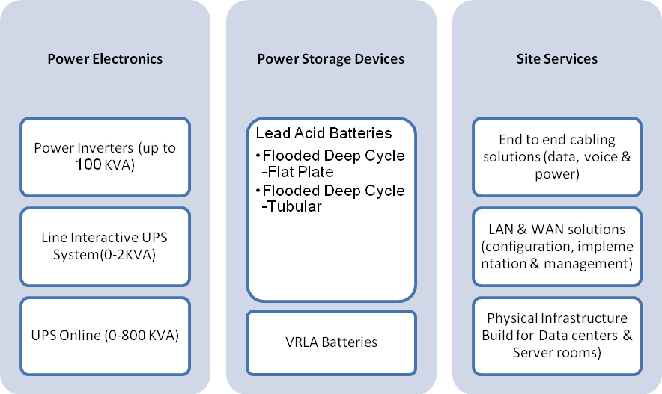

MANUFACTURING DIVISION

Inverter factory – INDIA:

- Power Electronic products – Baddi ( Home Inverters & UPS)
- Power Electronic products - Gagret – 3 (Home Inverters)

Battery factory – INDIA:

- Lead acid batteries, battery plates and components - village Ram Nagar, (Gagret)
- Electronics & Battery Assembly Unit (VRLA & Others) - Gagret Industrial area
- Tubular battery factory – INDIA

UPS factory – CHINA:

LPT is operating a manufacturing unit in Shenzhen (China) through its subsidiary, Lang Ming Power Technologies (Shenzhen) Ltd. for manufacturing Offline UPS, Online UPS and Power electronics products for global markets. This new facility is operational since June’08.

SUBSIDIARIES OF LUMINOUS

LPT has acquired UD Energy Systems Pvt. Ltd., a company engaged in the supply and installation of small-sized wind and solar hybrid power systems in early 2009. The company is the master distributor and Service Provider in India for South West Wind Power, USA, and world’s largest manufacturer of small wind turbines.
During 2009-10, LPT has also concluded the acquisition of Tritronics India Pvt. Ltd. New Delhi, a company engaged in the business of manufacturing and sales of UPS and catering to the business segment comprising of various Banks, Financial Institutions & Government of India establishments.
UD ENERGY SYSTEMS PVT. LTD.:

UD Energy Systems (P) Limited (UDE) incorporated in 2006 is now a subsidiary of Luminous Power Technologies (P) Ltd and is engaged in design, manufacture, supply, installation and servicing of all types of wind –solar, only wind and only solar photovoltaic power plants.

U D Energy Systems has been appointed as the Master Distributor and Service Provider of Southwest Windpower of USA, for India and adjoining countries. Southwest Windpower is the world’s largest manufacturer of small wind turbines with over 90,000 installations worldwide.
UDE is one of the very few renewable energy based hybrid systems solution providers in India.

TRITONICS INDIA:

Tritronics (India) Pvt. Ltd. was set-up in 1988 and is based in New Delhi. In July 2009, LPT acquired majority stake in the company. The company offers off-line, line-interactive, and on-line UPS systems; and constant voltage transformers.
The Company serves sectors such as telecom, banking and insurance, central and state government departments, and defence services
Other entities under the SAR group are:

- LUMINOUS ENGINEERING & TECHNOLOGY SERVICES PVT. LTD.:
Incorporated in 1997, Luminous Engineering & Technology Services P. Ltd. (LETS) is engaged in the business of providing Design Engineering services.

The mission of the company is to be amongst the top 10 back-office design engineering support services companies in India in the next 5 years, providing quality engineering services to a global customer base.

- LECTRIX MOTORS LTD.:
Incorporated in 2007, Lectrix Motors Limited (Lectrix) is a venture engaged in Electric Vehicle Business. At present, this venture is in the product development and start-up stage. The electric vehicle business in India is at a nascent stage. The industry is expected to grow by leaps and bounds once adequate support/ subsidy from the Government is available.

- LUMINOUS TELEINFRA LTD.:
Incorporated in 2008, Luminous Teleinfra Limited (LTI) is a venture engaged in passive infrastructure telecom products/ solution business.

- Wynn Telecom Limited:
WYNN Telecom Limited was incorporated on 1st December, 2009 and engaged is in the business of Trading of Mobile Handsets and Accessories.

.

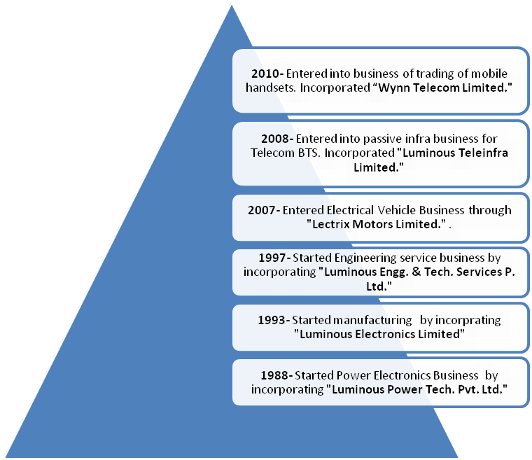
GROUP COMPANIES AND ITS PRODUCTS
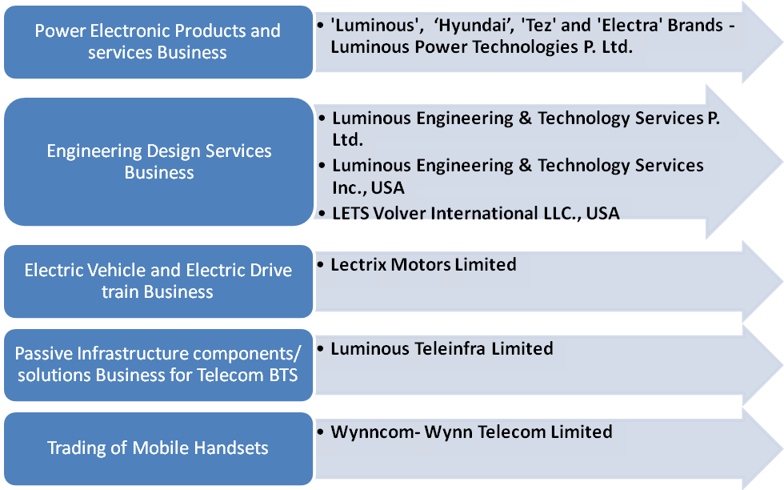

CHAPTER 2

OBJECTIVE OF PROJECT

OBJECTIVES
- To determine optimum amount of investment in current assets so that balance in profitability and liquidity of the business could be maintained.

- To manage Current assets and current liabilities in a manner so that working capital can be kept at a satisfactory level.

- To ensure that a firm is able to continue its operations and that it has sufficient ability to satisfy both maturing short-term debt and upcoming operational expenses.

- It helps in managing inventories, accounts receivable and payable, and cash.

CHAPTER 3

REVIEW OF LITERATURE

LITERATURE REVIEW
Once the problem is formulated a brief summary of it should be written down. The researcher should undertake extensive literature survey connected with the problem. For this problem, the abstracting and indexing journals and published or unpublished bibliographic are the first place to go to. Academic journals, conference proceedings, government reports, books etc must be tapped depending upon nature of problem.
Conceptual literature:-
Conceptual literature is that which relates with concepts and theories. Help from different books should be taken for different concepts and theories.
Empirical literature:-
Empirical literature consists of study made by other in the same field. The published data in newspapers books & magazines available for discussion with people of organization.

Harris (2005) from the perspective of the chief financial officer, the concept of working capital management is relatively straightforward: to ensure that the organization is able to fund the difference between short-term assets and short-term liabilities. In practice, though, working capital management has become the Achilles' heel of scores of finance organizations, with many CFOs struggling to identify core working capital drivers and the appropriate level of working capital.
As a result, companies can be limited in their ability to weather unforeseen or adverse events and ensure that cash is readily available where it is needed, regardless of the circumstances. By understanding the role and drivers of working capital management and taking steps to reach the "right" levels of working capital, companies can minimize risk, effectively prepare for uncertainty and improve overall performance.

M.K. Kolay (1997) writes the article which analyses the “pros” and “cons” of different strategies to be adopted to manage and avoid working capital crisis situations in any organization. The working capital position depends on many organizational parameters which are interrelated and interdependent, and also vary over time. In such a situation, the use of a system dynamics approach has been advocated to reflect the relevant dynamic cause-and-effect relationships for the development of appropriate long-term and short-term strategies.

Brent Finlay states that avoiding the top 7 business financing mistakes is a key component in business survival. The key is to understand the causes and significance of each so that the company is in a position to make better decisions.
(1) No Monthly Bookkeeping
Regardless of the size of your business, inaccurate record keeping creates all sorts of issues relating to cash flow, planning, and business decision making. While everything has a cost, bookkeeping services are dirt cheap compared to most other costs a business will incur. And once a bookkeeping process gets established, the cost usually goes down or becomes more cost effective as there is no wasted effort in recording all the business activity. By itself, this one mistake tends to lead to all the others in one way or another and should be avoided at all costs.
(2) No Projected Cash Flow
No meaningful bookkeeping creates a lack of knowing where you've been. No projected cash flow creates a lack of knowing where you're going. Without keeping score, businesses tend to stray further and further away from their targets and wait for a crisis that forces a change in monthly spending habits. Even if you have a projected cash flow, it needs to be realistic. A certain level of conservatism needs to be present, or it will become meaningless in very short order.

(3) Inadequate Working Capital
No amount of record keeping will help you if you don't have enough working capital to properly operate the business. That's why it’s important to accurately create a cash flow forecast before you even start up, acquire, or expand a business. Too often the working capital component is completely ignored with the primary focus going towards capital asset investments. When this happens, the cash flow crunch is usually felt quickly as there is insufficient funds to properly manage through the normal sales cycle.
(4) Poor Payment Management
Unless you have meaningful working capital, forecasting, and bookkeeping in place, you're likely going to have cash management problems. The result is the need to stretch out and defer payments that have come due. This can be the very edge of the slippery slope. I mean, if you don't find out what's causing the cash flow problem in the first place, stretching out payments may only help you dig a deeper hole. The primary targets are government remittances, trade payables, and credit card payments.
(5) Poor Credit Management
There can be severe credit consequences to deferring payments for both short periods of time and indefinite periods of time. First, late payments of credit cards are probably the most common ways in which both businesses and individuals destroy their credit.
Second, NSF checks are also recorded through business credit reports and are another form of black mark. Third, if you put off a payment too long, a creditor could file a judgment against you further damaging your credit. Fourth, when you apply for future credit, being behind with government payments can result in an automatic turndown by many lenders.
(6) No Recorded Profitability
For startups, the most important thing you can do from a financing point of view is get profitable as fast as possible. Most lenders must see at least one year of profitable financial statements before they will consider lending funds based on the strength of the business. Before short term profitability is demonstrated, business financing is based primary on personal credit and net worth. For existing businesses, historical results need to show profitability to acquire additional capital. The measurement of this ability to repay is based on the net income recorded for the business by a third party accredited accountant. In many cases, businesses work with their accountants to reduce business tax as much as possible but also destroy or restrict their ability to borrow in the process when the business net income is insufficient to service any additional debt.
(7) No Financing Strategy
A proper financing strategy creates 1) the financing required to support the present and future cash flows of the business, 2) the debt repayment schedule that the cash flow can service, and 3) the contingency funding necessary to address unplanned or unique business needs. Because financing is largely an unplanned and after the fact event. It seems once everything else is figured out, then a business will try to locate financing. There are many reasons for this including: entrepreneurs are more marketing oriented, people believe financing is easy to secure when they need it, the short term impact of putting off financial issues are not as immediate as other things, and so on.
Regardless of the reason, the lack of a workable financing strategy is indeed a mistake. However, a meaningful financing strategy is not likely to exist if one or more of the other 6 mistakes are present. This reinforces the point that all mistakes listed are intertwined and when more than one is made, the effect of the negative result can become compounded.

Arzu Tektas et al (2005) states that – An efficient asset-liability management requires maximizing banks' profit as well as controlling and lowering various risks. This multi-objective decision problem aims to reach goals such as maximization of liquidity, revenue, capital adequacy, and market share subject to financial, legal requirements and institutional policies. This paper models asset and liability management (ALM) in order to show how different managerial strategies affect the financial wellbeing of banks during crisis.
Maynard E. Rafuse (1996) Argues that attempts to improve working capital by delaying payment to creditors is counter-productive to individuals and to the economy as a whole. He claims that altering debtor and creditor levels for individual tiers within a value system will rarely produce any net benefit. Proposes that stock reduction generates system-wide financial improvements and other important benefits. Urges those organizations seeking concentrated working capital reduction strategies to focus on stock management strategies based on “lean supply-chain” techniques.

BOOKS:
- Mittal.R.K,“Management Accounting & Financial Management”:- The knowledge I have taken is explanation about the preparing of capital structure and way of interpreting it.
- Beri G.C., “Marketing Research”: Marketing Research 3rd edition: This book helped in understanding the different research designs and analytical tools used here.
- Ciaran Walsh, “Key Management Ratios”:- I have taken the knowledge about the analysis of liquidity of any firm by calculating current & liquid ratio.
- Jain T.R, “Statistics for MBA” V.K publication:- By going through this book I got information about how to calculate Regression Analysis and its application in the business studies.
- Khan M.Y, Jain P.K, “Management Accounting”:- It describes and explains the formulation of various ratios which give knowledge about the financial soundness of the business organization and their interpretation.
- Gupta C.B. "Management theory and practice”:- By studying this text book, I come to know about the personnel at various levels in the organization & responsibilities of the key personnel towards these employees and basic knowledge about the various departments of the manufacturing unit.
- Luck J. David⁽¹⁴⁾, “Marketing Research”: from this book I got light on the meaning of the marketing research & data collection.

CHAPTER 4
RESEARCH METHODOLOGY

RESEARCH METHODOLOGY

A Research Design is the framework or plan for a study which is used as a guide in collecting and analyzing the data collected.
The basic objective of research cannot be attained without a proper research design. It specifies the methods and procedures for acquiring the information needed to conduct the research effectively. It is the overall operational pattern of the project that stipulates what information needs to be collected from which sources and by what method.

RESEARCH DESIGN : DESCRIPTIVE

TYPE OF DATA USED
SECONDARY DATA: - The secondary data as it has always been important for the completion of any report provides a reliable, suitable, adequate and specific knowledge. The standard cost reports, working sheets provide the knowledge and information regarding the relevant subjects.
For this study, Scholar got data from the Finance Department i.e. Annual Reports and Account Statements of previous years and with the discussion held with the officers of Finance Department.
NATURE OF STUDY :
This study is limited to one organisation and it is exploratory in nature. The main objective of the study is to analysis of the working capital management of LUMINUOUS POWER .
TYPES OF DATA NEEDED:
Here in this study Scholar used secondary data that is collected from the Annual Reports, Financial Statements, manuals and other information provided by the finance department of the organisation under study in addition to the books, magazines, journals etc.

SAMPLING UNIT & SAMPLE TECHNIQUE :

LUMINOUS POWER

SAMPLE SIZE :

Scholar used secondary data from the Finance Department of the Company for study, so there is no direct interview or questionnaire put to respondents. Therefore, no particular respondent size is fixed for the study.
SAMPLING TECHNIQUE:
For this study of Working Capital Management, Scholar used Convenience Sampling Method technique.
SCOPE / AREA OF STUDY :
For the study of Working Capital Management (W.C.M.), Scholar have selected LUMINUOUS which is one of the best power products manufacturer company in the country under the name.

This study will certainly help to lUMINUOUS to make its future financial planning according to its working capital status.

LIMITATIONS OF THE STUDY

- 1) QUALITATIVE INFORMATIONS

All the analysis is based on quantitative information. And there are no much importance given to qualitative information.

- 2) HISTORICAL DATA

All the study is based on historical data so that it has no more importance.

- 3) TIME DURATION

All the staff of Luminuous was very efficient and cooperative and they have devoted enough time on us. But because of time limit we are not able to devote as much time with the employee.

- 4) SECRACY

Some of the information was kept confidential and was not disclosed to any person whosoever.

CHAPTER 5
WORKING CAPITAL MANAGEMENT

PROJECT STUDY- WORKING CAPITAL MANAGEMENT

Meaning of working capital:
Working capital also called fund which is the excess of current assets over current liabilities. All organizations have to carry working capital in one form or the other. The efficient management of working capital is important from the point of view of both liquidity and profitability. Poor management of working capital means that funds are unnecessarily tied up in idle assets hence reducing liquidity and also reducing the ability to invest in productive assets such as plant and machinery, so affecting the profitability. The working capital management refers to management of the working capital, or to be more precise, the management of current assets. The WCM refers to the management of the level of all these individual current assets.
The need for the WCM arises from two considerations.
- Existence of working capital is imperative in any organization. The fixed assets which usually partake a large chunk of total funds can be used at an optimum level only if supported by sufficient working capital, and
- The working capital involves investment of funds of the organization. If the working capital level is not properly maintained and managed, then it may result in unnecessary blocking of scare resources of the organization. The insufficient working capital, on the other hand, put different hindrances in smooth working of the organization. Therefore, the working capital management needs attention of all the financial managers.
The working capital management includes the management of the level of individual current assets as well as the management of total working capital. However, each individual current asset has unique characteristics which the financial manager must consider in deciding how much money should be invested in each of these current assets. The management of individual current assets i.e., cash and bank balance, marketable securities, receivables and inventories has been taken up in these projects.

NATURE OF WORKING CAPITAL:
The term working capital refers to current assets which may be defined as
- Those which are convertible into cash or cash equivalents within a period of one year.
- Those which are required to meet day to day operations. In working capital management a financial manager is faced with a decision involving some of the considerations as follows:
- What should be the total investment in working capital of the organization?
- What should be the level of individual current assets?
- What should be the relative proportion of different sources to finance the working capital requirements?
The term working capital may be used in two different ways:

(a) GROSS WORKING CAPITAL (TOTAL WORKING CAPITAL). The gross working capital refers to the organization’s investment in all the current assets taken together. The total of investments in all the individual current assets is the gross working capital. For example, if a organization has cash balance of Rs. 50000, debtors of Rs. 70000 and inventory of raw material and finished goods has been assessed at Rs. 100000 then the gross working capital of the organization is Rs. 220000
(b) NET WORKING CAPITAL: The term net working capital may be defined as the excess of total current assets over total current liabilities. It may be noted that the current liabilities refer to those liabilities which are payables within 1 year. The extent, to which the payments to these current liabilities are delayed, the organization gets the availability of funds for that period. So, a part of the funds required to maintain current assets is provided by the current liabilities and the organization will be required to invest the funds in only those current assets which are not financed by the current liabilities.
The distinction between gross working capital and net working capital does not in any way undermine the relevance of the concepts of either gross or net working capital. The gross working capital denotes the total working capital or the total investment in current assets. A organization should maintain an optimum level of gross working capital. This will help avoiding (i) the unnecessarily stoppage of work or chance of liquidation due to insufficient working capital and (ii) effect on profitability.
On the other hand, net working capital refers to the amount of funds that must be invested by organization, more or less, regularly in current assets. The net working capital also denotes the net liquidity being maintained by the organization.

WORKING CAPITAL CYCLE:
The working capital requirement of a organization depends, to a great extent upon the operating cycle of the organization. The operating cycle may be defined as the time duration starting from the procurement of goods or raw materials and ending with the sales realization. The length and nature of the operating cycle may differ from one organization to another depending upon the size and nature of the organization. The operating cycle of a organization consists of the time required for the completion of the chronological sequence of some or all of the following:
- Procurement of raw materials and services.
- Conversion of raw materials into work-in-progress.
- Conversion of work-in-progress into finished goods.
- Sale of finished goods (cash or credit).
- Conversion of receivables into cash.

Working capital in manufacturing concern:

1. Raw Material

2. WIP 6. Cash

3. Finished goods 5. Debtors

4. Sale

Working capital in trading concern:

1. Finished goods

2. Sales 4. Cash

3. Debtors

The only differences between the working capital cycle of manufacturing and trading concern is the additional types of inventory like raw materials, work in progress. These stocks are used for the manufacturing of the finished goods for the trading purpose.

TYPES OF WORKING CAPITAL :
The important aspects of working capital management are to analyze the total working capital needs of the organization in order to find out the permanent and temporary working capital. It has already been discussed that the working capital is required because of existence of working capital cycle. Moreover, the lengthier the operating cycle, greater would be the need for working capital. The operating capital is a continuous process and therefore, the working capital is needed constantly and regularly.

Permanent Working Capital
There is always a minimum level of working capital which is continuously required by a organization in order to maintain its activities. Every organization must have a minimum of cash, stock and other current assets in order to meet its business requirements irrespective of the level of operations. Even during slack season, every organization maintains some all the times, is known as permanent working capital for the organization.

Temporary working capital
Over and above the permanent working capital, the organization may also require additional working capital in order to meet the requirements arising out of fluctuations in sales volume. This extra working capital needed to support the increased volume in sales is known as temporary or fluctuating working capital. For example, in case of spurt in sales, more stock must be maintained in order to meet the demand. This additional inventory may become excess when the normal sales level reappears after some time.

FACTORS AFFECTING WORKING CAPITAL :-
It has already been known that an efficient manager has to ensure the optimum utilization of working capital. In doing so he has to plan his working capital requirement in advance so that he can ensure a proper financing mix. A organization has to neither plan its operations in such a way that it does not become handicapped for lack of necessary working capital nor can it allow too much working capital to circulate. The total working capital requirement of a organization is determined by a number of factors, some internal and some external. These factors, again, may vary from organization to organization and over a period of time. These are the following factors as under:-
- Nature of Business: The general nature of business will have a bearing upon the requirement of working capital of a organization. For example, public utilities will continue satisfactorily with small working capital partly because of the cash nature of their business and partly because of the fact that they render service instead of producing a product as a result of which there is no need for carrying big inventories. A manufacturing concern will have to invest more money as working capital because the” money lock period” is still longer here.

- Scale of Operation: Between two organizations engaged in the same type of business, the working capital requirement will vary depending upon the level of activity or scale of operation. Organizations operating at a higher activity level will require more working capital than others operating, say at a lower level of activity. Therefore, the scale of operation will also govern the working capital requirement of a organization.

- Production Cycle: This means the time involved in manufacturing or processing a product. It may be stated that the longer the production cycle, the larger will be the funds tied up in inventories and consequently the larger will be the need for the working capital and vice versa. The length of the production cycle, however, depends upon the nature of its business. Sometimes, organizations manufacturing heavy machinery and equipment may minimize their investment in inventories or working capital taking advance payment from their customers against work orders.
- Business Cycle: The nature of the business cycle will have a bearing on the working capital requirement of a organization. The fluctuations in operations may be in two directions: upswing and downswing. During an upswing, the need for working capital will increase to meet the requirement of increased production and sales. On the other hand, during the downswing, the volume of working capital will automatically come down.

- Seasonality and production policy: The seasonal fluctuations are normally based on the two approaches:

(I) Steady production policy independent of fluctuations in demand for the products.
(II) Production policy in tune with the changing demands.

- Credit Policy: The credit policy of a organization that governs sales and purchases will also influence the volume of working capital. It may be observed that working capital requirement decreases as the credit period for the realization of debtors is reduced, on the other hand, and the period of payment of creditors is enhanced, on the other. Again, one of the purposes of granting credit to customers is to bring about a favorable impact on sales.

- Growth and Expansion: With the growth of organizations, capital expenditures are incurred to expand their capacities. This generally necessitates additional working capital although a precise relation between the two, i.e., increase in volume of activity due to growth and that in working capital requirement, may be difficult to establish. But it must be emphasized that if a organization does not make a provision for the necessary working capital while embarking upon expansion or new projects, its investment in fixed assets may remain idle for lack of working capital.

- Rise in Price Level: Continuous rise in price levels has become a regular phenomenon, of not only the Indian economy but of many countries of the world. Therefore, an increase in the prices of inputs will necessitate additional working capital to maintain the same volume of activity. Any working capital planning must take care of this aspect or else, a organization will have to cut down its level of activity if it does not make a provision for an increase in price levels while planning its working capital requirements.

- Operating Efficiency: It is one of the important factors to be considered while planning working capital requirement of a organization. It has been stated earlier that the requirement of working capital by a organization should increase at a rate lower than that of an increase in output. Even making an allowance for a rise in the price level, there should be such an acceleration of the flow of working capital that there is a constant economy in its use.

10) Availability of Raw Materials: If the supply of raw materials is irregular or seasonal, then in order to ensure an uninterrupted production schedule, raw materials may have to be procured in time and stored far in advance of actual consumption. With a rise in inventory level, additional funds are tied up. On the other hand, when raw materials are available regularly, the average investment in time in working capital will be lower than that in the former case.

COMPONENT OF WORKING CAPITAL:-

CASH MANAGEMENT
MEANING: Every business has to maintain a cash balance to meet needs that can be managed only with cash. The convenience and liquidity associated with keeping cash also carries a cost, however, for cash does not earn a return for the business. Some businesses hold cash equivalents, such as Treasury Bills, which provide almost all of the convenience of cash but also earn a return for the holder, albeit one lower than earned by the business on real projects.
Cash management refers to management of cash balance and the bank balance and also includes the short terms deposits. The cash is obviously the most important current assets, as it is the most liquid and can be used to make immediate payments. Insufficiency of cash at any stage may prevent a organization from discharging its liabilities or force it to sell its other assets immediately.
A financial manager is required to manage the cash flows arising out of the operations of the organization. For his he will have to forecast the cash inflows from sales and outflows for costs etc. This will enable the financial manager to identify the timings as well as amount of future cash flows. Cash management does not end here and the financial manager may also be required to identify the sources from where cash may be procured on a short term basis or the outlets where excess cash may be invested for a short term.

MOTIVES FOR HOLDING CASH:
- Transaction Motive: Business organizations as well as individuals keep cash because they require it for meeting demand for cash flow arising out of day to day transactions. In order to meet the obligations for cash flows arising in the normal course of business, every organization has to maintain adequate cash balance. A organization requires cash for making payments for the purchase of goods and services.

- Precautionary Motive: The precautionary motive for holding cash is based on the need to maintain sufficient cash to act as a cushion or buffer against unexpected events.

- Degree of predictability of its cash flows,
- Its willingness and capacity to take risk of running short of cash, and
- Available immediate borrowing powers.

- Speculative Motive: Cash may be held for speculative purposes in order to take advantage of potential profit making situations. A organization may be come across an unexpected opportunity to make profit, which is not usually available in normal business routine. Some cash balance may be kept to take advantage of these windfalls e.g., an opportunity to purchase raw materials at a heavy discount, if paid in cash.

- Compensation Motive: Commercial banks require that in every current account, there should always be a minimum cash balance. Presently, this minimum cash balance varies from Rs 3000 to Rs 5000. This amount remains as a permanent balance with the bank so long as the current account is operative. This minimum balance is generally not allowed by the bank to be used for transaction purposes and therefore, it becomes a sort of investment by the organization in the bank.

OBJECTIVE OF CASH MANAGEMENT :-

There are two basic objectives of cash:

- Meeting the cash outflows: The primary objective of cash management is to ensure the cash outflows as and when required. Enough cash must be on hand to meet the disbursal needs that arise in the normal course of business. It will help the organization in

- Avoiding the chance of default in meeting financial obligations, otherwise the goodwill of the organization is adversely affected.
- Availing the opportunities of getting cash discounts by making early or prompt payments.
- Meeting unexpected cash outflows without much problem.

- Minimizing the cash balance: Investment in idle cash balance must be reduced to a minimum. The objective of cash management is based on the idea that unused asset earns no income for the organization. The funds locked up in cash balance are a dead investment and has no earnings. Therefore, whatever cash balance is maintained, the organization is foregoing interest income on that balance.

FACTORS AFFECTING THE CASH NEEDS
It has already been said that the financial manager has to achieve a tradeoff between liquidity and profitability and in doing so he should note that there are various factor which will determine the amount of cash balance to be kept by the organization.
- Cash Cycle: The term cash cycle refers to the length of the time between the payment for purchase of raw material and the receipt of sales revenue. So, the cash cycle refers to the time that elapses from the point when the organization makes an outlay to purchase raw materials to the point when cash is collected from the sale of finished goods produced using that raw material.

- Cash Inflows and Cash Outflows: Every organization has to maintain cash balance because its expected inflows and outflows are not always synchronized. The timings of the cash inflows may not always match with the timing of the outflows. Therefore, a cash balance is required to fill up the gap arising out of difference in timings and quantum of inflows and outflows.

- Cost of cash balance: Another factor to be considered while determines the minimum cash balance is the cost of maintaining excess cash or of meeting shortages of cash. There is always an opportunity cost of maintaining excessive cash balance. If a organization is maintaining excess cash then it is missing the opportunities of investing these funds in a profitable manner.

CASH MANAGEMENT CONTROL ASPECTS :

- Controlling inflows: The financial manager should take steps for speedy recovery from debtors and for this purpose proper internal control system should be installed in the organization. Once the credit sales have been affected, there should be a built-in mechanism for timely recovery from the debtors.
- Controlling outflows: An effective control over cash outflows or payments also help a organization in better cash management and reducing cash requirements. A financial manager should try to slow down the payments as much as possible. However, care must be taken that the goodwill and credit rating of the organization is not affected. Payments to creditors need not be delayed otherwise it may be difficult to secure trade credits at a later stage.

- Playing the Float: with reference to the control of inflows and outflows, float is an important technique to lessen the length of cash cycle. When a organization receives or makes payments in the form of cheques etc., there is usually a time gap between the time the cheques are written and when it is cleared. This time gap is known as float.
RECEIVABLES MANAGEMENT :-
MEANING:
Accounts receivable are simply extensions of credit to the organization’s customers, allowing them a reasonable period of time in which to pay for goods. Most organizations treat account receivable as a marketing tool to promote sales and profits. The financial officer must analyze how much the organization should invest in account receivable, for there is always a temptation to extend too much credit in an effort to boost sales beyond the point where the return on the investment in account receivable is no longer as attractive as the return on other investment opportunities. It is the financial officer’s responsibility to guard against over investment in account receivable.
The receivable including the debtors and the bills constitute a significant portion of the working capital and is an important element of it. The receivables emerge whenever goods are sold on credit and payments are delayed by customers.
COSTS OF RECEIVABLES:
- Cost of Financing: The credit sales delays the time of sales realization and therefore the time gap between incurring the cost and sales realization is extended. This results in blocking of funds for a long period. The organization on the other hand, has to arrange funds to meet it owns obligation towards payment to the supplier, employs etc.

- Administrative Cost: A organization will also be required to incur various costs in order to maintain the record of credit customers both before the credit sales as well as after the credit sales. Before credit sales, cost are incurred on obtaining information regarding credit worthiness of the customers; while after credit sales, the cost are incurred on maintaining the record of credit sales and collection thereof.

- Delinquency Cost: Over and above the normal administrative cost of maintaining and collection of receivables, the organization may have to incur additional costs known as delinquency costs, if there is delay in payment by a customer. The organization may have to incur cost on reminders, phone calls, postage, legal notice etc.

- Cost of Default by Customer: If there is a default by customer and the receivable becomes, partly or wholly, unrealizable, then this amount, known as bad debt, also becomes a cost to the organizations. The cost does not appear in case of cash sales.
BENEFITS OF RECEIVABLES:
- Increase in Sales: Except a few monopolistic organizations, most of the organizations are required to sell goods on credit, either because of trade customs or other conditions. The sales can further be increased by liberalizing the credit terms.

- Increase in Profit: Increase in sales will help in the organization (I) to easily recover the fixed expenses and attaining the break even level, and (II) increase the operating profit of the organization. In a normal situation there is a positive relation between the sales volume and the profit.

- Extra Profit: sometimes, the organizations make the credit sales at a price which is higher than the usual cash selling price. This brings an opportunity to the organization to make extra profit over and above the normal profit.

CREDIT SYSTEM OF RECEIVABLE MANAGEMENT DEPENDS ON :

CREDIT POLICY: A organization makes significant investment by extending credit to its customers and thus requires a suitable and effective credit policy to control the level of the total investment in the receivable and effective credit policy to control the level of total investment in the receivables. The basic decision to be made regarding receivables is to decide how much credit be extended to a customer and on what terms. This is what is known as the credit policy.
- Credit Standard: When a organization sells on credit, it takes a risk about the paying capacity of the customers. Therefore, to be on a safer side, it must set credit standard which should be applied in selecting customers for credit sales. The following points are worth noting while setting the credit standard for a organization:
- Effect of a particular standard on the sales volume.
- Effect of a particular standard on the total bad debts of the organization.
- Effect of a particular standard on the total collection cost.

- Credit Terms: The credit terms refers to the set of stipulations under which the credit is extended to the customers. While the custom of the market frequently dictate the nature of the credit terms and conditions offered by a organization, the organization, nevertheless, can design its own credit terms as a dynamic instruments in its overall sales efforts. The credit terms specify how the credit will be offered, including the length of the period for which the credit will be offered, the interest rate on the credit, and the cost of default.
CREDIT EVALUATION: The receivables are generally considered a relatively low risk asset. The basic risk is due to the possibility that the organization will not be able to collect all that is due to it by the customers. Under normal circumstances, the total bad debts losses a organization will experience can be forecast with reasonable accuracy, especially if the organization sells to large number of customers and does not change its credit policies.
Credit evaluation included the determination of the types of customers who are going to qualify for the trade credit. Several costs are associated with extending credit to less credit-worthy customers. As the probability of default increases, it becomes more important to identify which of the possible new customers would be risky. When more time is spent investigating the less credit worthy customers, the cost of credit investigation increases.
Evaluation of credit worthiness of a customer is a two steps procedure
- Collection of information.
- Analysis of information.
CONTROL OF REEIVABLES:
- The Collection Procedure: Once a organization decides to extend credit and defines the terms of credit sales, it must be develop a policy for dealing with delinquent or slow paying customers. There is a cost of both: Delinquent customers create bad debts and other costs associated with the repossession of goods, whereas the slow paying customers cause more cash being tied up in receivables and the increased interest cost.

- Monitoring of Receivables: In order to control the level of receivables, the organization should apply regular checks and there should be a continuous monitoring system. The financial managers should keep a watch on credit worthiness of all the individual customers as well as on the total credit policy of the organization.
INVENTORY MANAGEMENT:-
MEANING
Inventories are assets of the organization, and as such they represent an investment. Because such investment requires a commitment of funds, managers must ensure that the organization maintains inventories at the correct level. If they become too large, the organization loses the opportunity to employ those funds more efficiently. Similarly, if they are too small, the organization may lose sales. Thus, there is an optimal level of inventories and there is an economic order quantity model for determining the correct level of inventory.
TYPES OF INVENTORY
- Finished Goods: These are the goods which are either being purchased by the organization or are being produced or processed in the organization. These are just ready for sale to customers. Inventories of finished goods arise because of the time involved in production process and the need to meet customer’s demand promptly. If the organizations do not maintain a sufficient finished goods inventory, they run the risk of losing sales, as the customers who are unwilling to wait may turn to competitors.

- Work-in-progress: It refers to the raw materials engaged in various phases of production schedule. The degree of completion may be varying for different units. Some units might have been just introduced, while some others may be 40% complete or others may be 90% complete. The work-in-progress refers to partially produced goods. The value of work-in-progress includes the raw material costs, the direct wages and expenses already incurred and the overheads, if any. So, the work-in-progress inventory contains partially produced/completed goods.

- Raw Materials: The raw materials include the materials which are used in the production process and every manufacturing organization has to carry certain stock of raw materials in stores. These units of raw materials are regularly issued/transferred to production department. Inventories of raw materials are held to ensure that the production process is not interrupted by a shortage of these materials. The amount of raw materials to be kept by a organization depends on a number of factors, including the speed with which raw materials can be ordered and procured.
HOLDING OF INVENTORY
- Transactionary Motive: Every organization has to maintain some level of inventory to meet the day to day requirements of sales, production process, customer demand etc. This motive makes the organization to keep the inventory of finished goods a well as raw materials. The inventory level will provide smoothness to the operations of the organization.

- Precautionary Motive: A organization should keep some inventory for unforeseen circumstances also. For example, the fresh supply of raw material may not reach the factory due to strike by the transporters or due to natural calamities in a particular area. There may be labor problem in the factory and the production process may halt. So, the organization must have inventories of raw materials as well as finished goods for meeting such emergencies.

- Speculative Motive: The organization may be tempted to keep some inventory in order to capabilities an opportunity to make profit e.g.. Sufficient level of inventory may help the organization to earn extra profit in case of expected shortage in the market.

Reasons and Benefits of Inventories:
- Trading Organization: In case of a trading organization, there may be several reasons why it will maintain inventory. If the organization has some stock of goods then the sales activity can undertaken even if the procurement has stopped due to one reason or the other. Otherwise, if stock is not there, there is a likelihood that the sales will stop as soon as as there is an interruption in procurement. Moreover, it is not always possible to procure the goods whenever there is a sales opportunity, as there is always a time gap required between the purchase and sale of goods.

- Manufacturing Organization: A manufacturing organization should have inventory of not only the finished goods, but also of raw materials and work-in-progress for obvious reasons as follows:
- Uninterrupted production schedule. Every manufacturing organization must have sufficient stock of raw materials in order to have the regular and interrupted production schedule. If there is stock out of raw materials at any stage of production process, then the whole production process may be come to halt.
- Independent Sales activity: Inventory of finished goods is required not only in a trading concern, but manufacturing organizations should also have sufficient stock of finished goods. The production schedule is generally a time consuming process and in most of the cases goods cannot be produced just after receiving orders.
Cost of Inventory:
Every organization maintains some stock of raw materials, work-in-progress and finished goods depending upon the requirement and other features of the organization. It is benefited by holding inventory, no doubt, yet it must also consider various costs involved in holding inventories.
The cost of holding inventories may include the followings:
- Carrying Cost: This is the cost incurred in keeping or maintaining an inventory of one unit of raw material or work in progress or finished goods. Two basic costs are associated with holding a unit in inventory. These are
- Cost of Storage: This means and includes the cost of storing one unit of raw material by the organization. This cost may be in relation to rent of space occupied by the stock, the cost of people employed for the security of the stock, cost of pilferage, warehousing costs, handling cost etc.
- Cost of Financing: This cost includes the cost of funds invested in the inventories. The funds used in the purchase/production of inventories have an opportunity cost i.e., the income which could have been earned by investing these funds elsewhere. Moreover, if the organization has to pay interest on borrowing made for the purchase of materials/goods, then there is an explicit cost of financing in the form of interest.

- Cost of Ordering: The cost of ordering includes the cost of acquisition of inventories. It is the cost of preparation and execution of an order, including cost of paper work and communicating with the supplier. There is always minimum cost involved whenever an order for replenishment of goods is placed. The total annual cost of ordering is equal to the cost per order multiplied by the number of order placed in a year.

- Carrying Cost: The carrying cost and the cost of ordering are the opposite forces and collectively they determine the level of inventories in any organization. The carrying cost consideration requires that the organizations should maintain the inventories at the lowest level and should be replenished as frequently as possible. This will result in lowering of the total carrying cost.

WORKING CAPITAL MANAGEMENT OF LUMINOUS
The Working Capital Management of LUMINOUS is calculated over the last five years from 2006-2010. The net working capital method is followed for the calculation of working capital management. This method defined as the excess of total current assets over total current liabilities which are payable within the one year period.

TABLE 4.1: CALCULATION OF WORKING CAPITAL
Year |  | Current assets |  | Current liabilities |  | Gross working capital | Net working capital
2006 |  | 473791 |  | 433229 |  | 473791 | 40562
2007 |  | 1265608 |  | 1150014 |  | 1265608 | 115594
2008 |  | 2608333 |  | 1529093 |  | 2608333 | 1079240
2009 |  | 2614118 |  | 1362893 |  | 2614118 | 1251225
2010 |  | 2954738 |  | 1939624 |  | 2954738 | 1015114
Source: Compiled from balance sheet of luminous

FIGURE NO.: 4.1
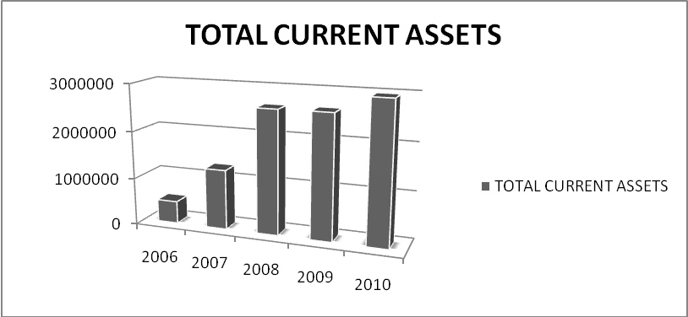

FIGURE NO.: 4.2
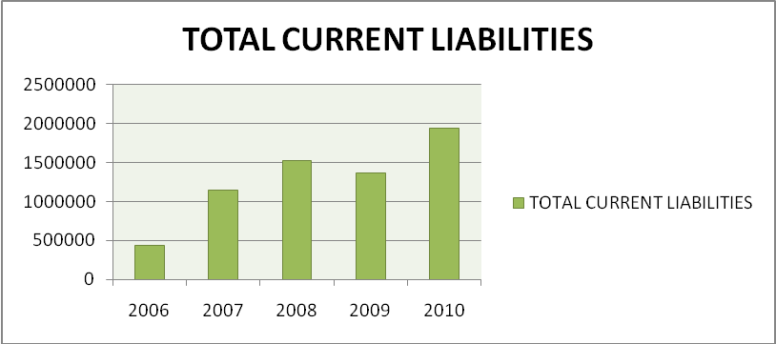
FIGURE NO.: 4.3
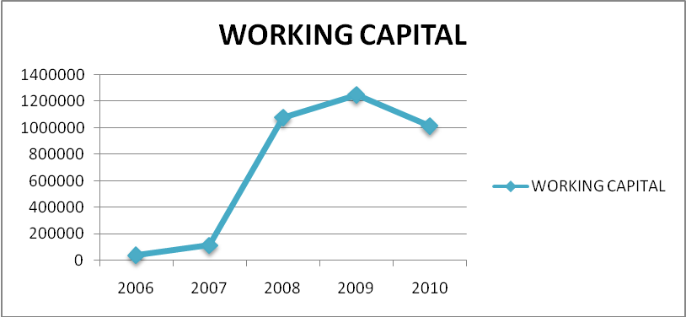
Interpretation:-
1. Other current assets includes interest accrued, loan given to supplier and other advance recoverable in cash.
2. Other liability includes statutory liability and cash credit or working capital drawing limit.
3 Creditors does not include creditors for capital goods as purchase does not include capital Vendors.
4 Provisions are also included in the Current liabilities.

As the above figure states that in year 2006 the company had net working capital of Rs.40562(in thousand) as compared to year 2010, which is Rs.1015114(in thousand). This shows that the organizations maintain the adequate working capital over the last five years as compared to the sales/ turnover.

Position of Total Assets and Total Liabilities of LUMINOUS :
The position of assets and liabilities in LUMINOUS are defined by the below financial tools:-

COMPARATIVE ANALYSIS (2009-2010)
When financial statements figures for two or more years are placed side by side to facilitate comparison, these are called “COMPARATIVE FINANCIAL STATEMENTS”. Such statements not only show the absolute figures of various years but also provide for columns to indicate the increase/decrease in these figures from one year to another. In addition, these statements may also show the change from one year to another in % format. Such comparative statement is of great value in forming the opinion regarding the progress of the enterprise.

TABLE NO.: 4.2
COMPARATIVE BALANCE SHEET
PARTICULARS | 2009 | 2010 | INC. or DEC. | % INC.  or DEC.
CURRENT ASSETS:
Inventories | 731159 | 928458 | 197299 | 26.98
Sundry debtors | 1594987 | 1540881 | -54106 | -3.39
Cash & bank bal. | 157091 | 349111 | 192020 | 122.23
Other current assets | 4527 | 2821 | -1706 | -37.68
TOTAL | 2487764 | 2821271 | 333507 | 13.40
Loans & advances | 339729 | 679980 | 340251 | 100.15
Deferred tax assets | 26042 | 57969 | 31927 | 122.59
Investment | 72282 | 204076 | 131794 | 182.33
Fixed assets :
Land | 13459 | 13459 | 0
Building | 129405 | 192609 | 63204 | 48.84
Building leasehold | 18634 | 17916 | -718 | -3.85
Computer | 5328 | 10664 | 5336 | 100.15
Furniture | 10201 | 13484 | 3283 | 32.18
Plant & machinery | 186059 | 354174 | 168115 | 90.35
Vehicles | 8458 | 12479 | 4021 | 47.54
Other fixed assets | 14496 | 17734 | 3238 | 22.33
Net Fixed Assets | 386040 | 632519 | 246479 | 63.84
Capital WIP | 78323 | 62367 | -15956 | -20.37
GRAND TOTAL | 3390180 | 4458182 | 1068002 | 31.50
LIABILITIES& CAPITAL:
Current liabilities
Creditors for goods | 594027 | 1029569 | 435542 | 73.32
Crs. Capital goods | 11960 | 28076 | 16116 | 134.74
Book overdrafts | 4867 |  | -4867 | -100
Advance from customers | 24981 | 44280 | 19299 | 77.25
Security deposits | 31670 | 30270 | -1400 | -4.42
Statutory liabilities | 45976 | 82438 | 36462 | 79.30
Other liabilities | 59129 | 93245 | 34116 | 57.69
Provision | 212187 | 340092 | 127905 | 60.27
TOTAL | 984797 | 1647970 | 663173 | 67.34
Loan funds
Secured loans | 599942 | 601155 | 1213 | 0.20
Capital & reserves
Share capital | 618785 | 618785 | 0 | 0
Reserves & surplus | 1186656 | 1590272 | 403616 | 34.01
TOTAL SHAREHOLDERS
FUNDS | 2405383 | 2810212 | 404829 | 16.83
TOTAL LIAB. & CAP. | 3390180 | 4458182 | 1068002 | 31.50

Source: Compiled From Balance Sheet Of Luminous

This has been observed that:
- Fixed Assets are increased by 63.84%.
- Current Assets are raised by 13.40%.
- Investments are improved by 182.33%
On the other hand, there is increase in liabilities from 2009 – 2010:
- Creditors are increased by 0.75%.
- Statutory liabilities & other liabilities are increased by 79.30% & 57.69% respectively.
- Advance from customer is also enlarged by 77.25%

SCHEDULE OF CHANGE IN WORKING CAPITAL:
According to this schedule, changes in working capital during the year are ascertained. It is found out at the end of year how much working capital has increased/decreased in comparison to the working capital in the beginning of the year. To calculate changes in working capital, current assets and current liabilities appearing on the opening day of the year are compared with those existing at the end of the year. If at the end of the year, current assets have decreased, the working capital is said to have decreased. Contrarily, if the current assets have increased at the end of the year, it will be called increase in working capital. On the other hand, if current liabilities increase, it will be decrease in working capital. If current liabilities decrease, it will be increase in working capital.
TABLE NO.: 4.3
SCHEDULE OF CHANGES IN WORKING CAPITAL
PARTICULARS | 2009 | 2010 | INCREASE | DECREASE
CURRENT ASSETS:
CASH & BANK BALANCES | 157091 | 349111 | 192020
SUNDRY DEBTORS | 1594987 | 1540881 |  | 54106
INVENTORIES | 731159 | 928458 | 197299
TOTAL OTHER CURRENT ASSETS | 130881 | 136288 | 5407
TOTAL CURRENT ASSETS | 2614118 | 2954738
CURRENT LIABILITIES:
SUNDRY CREDITORS | 594027 | 1029569
BANK OVERDRAFT | 4867 | 0 |  | 4876
ADVANCE FROM CUSTOMERS | 24981 | 44280 |  | 435542
OTHER LIABILITY | 526831 | 525683 | 1148
PROVISION | 212187 | 340092 |  | 19299
TOTAL CURRENT LIABILITIES | 1362893 | 1939624
NET WORKING CAPITAL (CA- CL) | 1251225 | 1015114 |  | 127905
NET DECREASE IN WORKING CAPITAL |  | 236111 | 236111
 | 1251225 | 1251225 | 636852 | 636852
Source: Data Taken From Annual Report

At the end of the year 2009 & 2010, current assets have increased, the working capital is said to have increased due to increase in cash & bank balance, inventories & other current assets. Contrarily, the current assets have decreased at the end of the year due to decrease in debtors; it will be called decrease in working capital. On the other hand, there is increase in other liability & bank overdraft, it will lead to increase in working capital and current liabilities increase cause of advance from customer & provisions, it will be decrease in working capital.
There is decrease in overall net working capital of luminous in the year 2009 – 2010 by Rs.236111 (in thousands). It shows that there is increase in net current assets but current liabilities have also increased more than increased in current assets of organizations in between 2009 – 2010.
Working Capital Cycle Of LUMINOUS
TABLE NO.: 4.4
WORKING CAPITAL CYCLE
RAW MATERIAL: | 2006 | 2007 | 2008 | 2009 | 2010
OPENING RAW MATERIAL | 2605 | 65711 | 262880 | 352636 | 258624
CLOSING RAW MATERIAL | 65711 | 262880 | 352636 | 258624 | 469857
AVERAGE RAW MATERIAL | 34158 | 164295.5 | 307758 | 305630 | 364240.5
TOTAL RAW MATERIAL | 247116 | 1429380 | 2720898 | 2884693 | 3917804
RAW MATERIAL CONVERSION PERIOD(Days) | 50 | 42 | 41 | 39 | 34
WORK IN PROGRESS: | 2006 | 2007 | 2008 | 2009 | 2010
OPENING WIP | 0 | 56221 | 124089 | 256150 | 171508
CLOSING WIP | 56221 | 124089 | 256150 | 171508 | 194245
AVERAGE WIP | 28110.5 | 90155 | 190119.5 | 213829 | 182876.5
RAW MATERIAL CONSUMED | 247116 | 1429380 | 2720898 | 2884693 | 3917804
PERSONNEL EXPENSES | 59080 | 125911 | 191733 | 282025 | 395730
MANUFACTURING EXPENSES | 14285 | 100442 | 112553 | 137034 | 185500
DEPRECIATION | 24361 | 50606 | 93665 | 157532 | 219630
TOTAL COST OF PRODUCTION | 288621 | 1638471 | 2986788 | 3545926 | 4695927
WIP CONVERSION PERIOD (Days) | 31 | 11 | 11 | 16 | 17
FINISHED GOODS: | 2006 | 2007 | 2008 | 2009 | 2010
OPENING FG | 86939 | 68568 | 63229 | 193303 | 301027
CLOSING FG | 68568 | 63229 | 193303 | 301027 | 264356
AVERAGE FG | 77753.5 | 65898.5 | 128266 | 247165 | 282691.5
COST OF PRODUCTION | 288621 | 1638471 | 2986788 | 3545926 | 4695927
SELLING & ADMINISTRATION EXPENSES | 176915 | 298059 | 416511 | 637369 | 871985
FINANCIAL EXPENSES | 15690 | 53116 | 80370 | 127036 | 85556
TOTAL COST OF SALES | 499597 | 1994985 | 3353595 | 4202607 | 5690139
FG CONVERSION PERIOD (Days) | 57 | 12 | 14 | 21 | 18
DEBTORS: | 2006 | 2007 | 2008 | 2009 | 2010
OPENING DEBTORS | 72228 | 237482 | 745826 | 1555104 | 1594987
CLOSING DEBTORS | 237482 | 745826 | 1555104 | 1594987 | 1540881
AVERAGE DEBTORS | 154855 | 491654 | 1150465 | 1575045.5 | 1567934
TOTAL CREDIT SALES | 1126183 | 2481046 | 4110784 | 4819601 | 6422097
DEBTORS CONVERSION PERIOD (Days) | 50 | 72 | 102 | 119 | 89
CREDITORS: | 2006 | 2007 | 2008 | 2009 | 2010
OPENING CREDITORS | 97563 | 255054 | 610885 | 931556 | 594027
CLOSING CREDITORS | 255054 | 610885 | 931556 | 594027 | 1029569
AVERAGE CREDITORS | 176308.5 | 432969.5 | 771220.5 | 762791.5 | 811798
TOTAL PURCHASE | 901353 | 1884942 | 3045514 | 3318097 | 4631411
CREDITOR CONVERSION PERIOD (Days) | 71 | 84 | 92 | 84 | 64
NET WORKING CAPITAL CONVERSION PERIOD: | 2006 | 2007 | 2008 | 2009 | 2010
RAW MATERIAL CONVERSION PERIOD (Days) | 50 | 42 | 41 | 39 | 34
WIP CONVERSION PERIOD (Days) | 31 | 11 | 11 | 16 | 17
FG CONVERSION PERIOD (Days) | 57 | 12 | 14 | 21 | 18
DEBTORS CONVERSION PERIOD (Days) | 50 | 72 | 102 | 119 | 89
CREDITOR CONVERSION PERIOD (Days) | 71 | 84 | 92 | 84 | 64
NWCCP (Days) | 117 | 53 | 76 | 111 | 94
sOURCE: COMPILED FROM AUDITORS REPORT

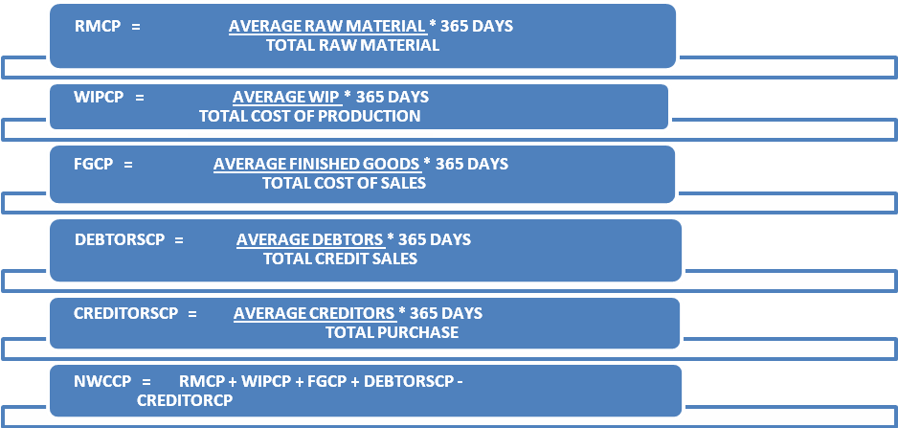

FIGURE NO.: 4.4
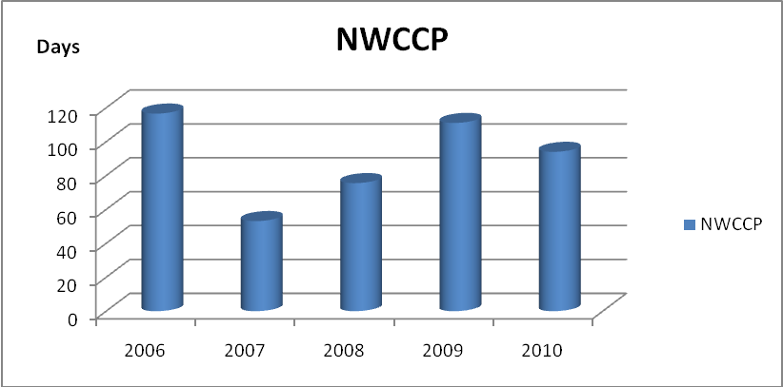

In the above figure, organization had consistently able to reduce the overall length of the working capital cycle including each and every element over the years. Constantly organization had made efforts to lower its WCC in order to maintain comfortable liquidity.
Component of Working Capital of LUMINOUS
Working capital comprises of following elements:
- Cash Management of Luminous.
- Inventory Management of Luminous.
- Receivable Management of Luminous.
TABLE NO.: 4.5
Cash Management of Luminous
CASH & BANK BALANCES | 2006 | 2007 | 2008 | 2009 | 2010
CASH IN HAND | 2105 | 713 | 988 | 963 | 1270
BALANCES WITH SCHEDULED BANKS
CURRENT ACCOUNTS | 9504 | 24617 | 125842 | 115737 | 308697
FIXED DEPOSITS | 17126 | 35622 | 45952 | 40391 | 39144
TOTAL CASH & BANK BALANCES | 28735 | 60952 | 172782 | 157091 | 349111

The total cash and bank balance of Luminous consists of the current accounts and fixed deposits with bank and cash in hand.
FIGURE NO.: 4.5
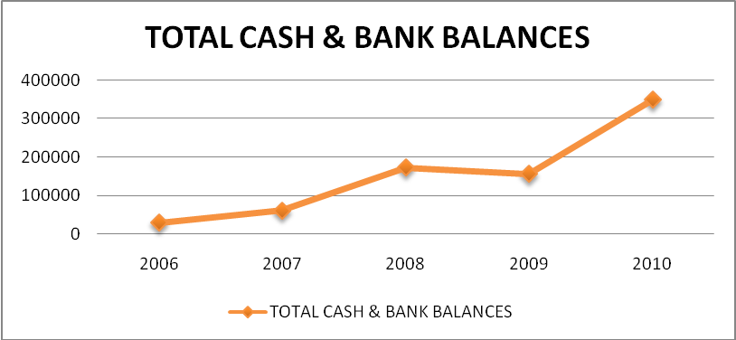

As the above figure indicates, the company’s total cash and bank balances shows increasing trend from year 2006 to year 2010.

TABLE NO.: 4.6
INVENTORY MANAGEMENT IN LUMINOUS:
Year | Raw Material | Work In Progress | Goods In Transit | Finished Goods | Total
2006 | 57075 | 56221 | 17047 | 60207 | 190550
2007 | 202532 | 124089 | 60348 | 63229 | 450198
2008 | 238431 | 256150 | 114205 | 193303 | 802089
2009 | 224115 | 171508 | 34509 | 301027 | 731159
2010 | 450689 | 194245 | 19168 | 264356 | 928458

Source: Compiled from Auditors Report

The total inventory consists of the raw materials, work in progress, finished goods and goods in transit. Inventory is very high in year 2010 i.e. 928458(in thousands) which were at a lower level in previous year from 2006 & 2009.
RAW MATERIALS:
The position of raw materials in company is highest in 2010 i.e. Rs 450689000 due to the increase of demand of Luminous products in Market. As Luminous is in trend of increasing its sales turnover to Rs.1000 crore they heavily invested in manufacturing of products.
Inventories of raw materials are held to ensure that the production process is not interrupted by a shortage of these materials.
WORK IN PROGRESS (SEMI FINISHED GOODS):
Company maintains high work in progress (semi finished goods) in year 2008 due to the goods being in manufacturing process. It may lead to the shortage of inventory as well the increase in manufacturing expenses.
The value of semi finished goods includes the raw material costs, the direct wages and expenses already incurred and the overheads, if any. The organization only maintains Rs.194245 (thousands) in year in comparison of their sales in 2010. The company is also being able to save all the expenses during previous years.
The quantity and value of the semi finished goods depends on the length of the production cycle. In case of shorter production cycle, the semi finished goods may be of a lower value but if the production cycle is lengthy, the organization will be having a high work in progress. The more complex and lengthy is the production process, higher the investment in WIP inventory.
FINISHED GOODS:
The finished goods are highest in the year 2009 i.e. Rs. 301027(thousand). It was in increasing trend from year 2006 and reaches its maximum position in the year 2009. Higher finished goods indicate the demand of luminous product in the market which would be supplemented by increasing sales.
GOODS IN TRANSIT:
Goods that have been dispatched from the suppliers ends, but have not yet arrived at the receipt, offloading, or delivery point. The goods are of mainly raw material goods and not capital goods.
STOCK IN TRANSIT-
Also called as in transit inventory. It comprises of finished and semi finished goods transfer from plants to storage location.
FIGURE NO.: 4.6
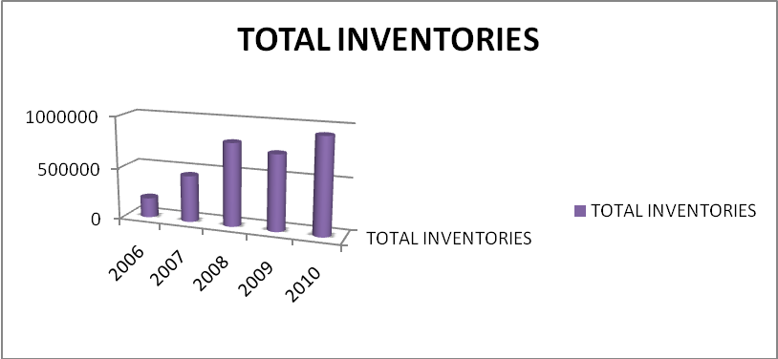

In the above figure, the company maintains the inventory level as per the needs and requirement of goods in the market or depending on the production plants.
TABLE NO.: 4.7
RECEIVABLE MANAGEMENT IN LUMINOUS:
SUNDRY DEBTORS | 2006 | 2007 | 2008 | 2009 | 2010
OUTSTANDING MORE THAN 6 MONTHS
UNSECURED, CONSIDERED GOODS | 11216 | 27880 | 64225 | 122708 | 151565
SECURED, CONSIDERED GOODS | 0 |  | 435 | 4050 | 4000
UNSECURED, CONSIDERED DOUBTFUL | 2816 | 17753 | 32279 | 47130 | 81579
OUTSTANDING LESS THAN 6 MONTHS
SECURED, CONSIDERED GOODS | 27165 | 63446 | 30441 | 34634 | 29467
UNSECURED, CONSIDERED GOODS | 199101 | 624500 | 1460003 | 1433595 | 1355849
TOTAL | 240298 | 733579 | 1587383 | 1642117 | 1622460
LESS: PROVISION FOR DOUBTFUL DEBTS | 2816 | 17753 | 32279 | 47130 | 81579
TOTAL SUNDRY DEBTORS | 237482 | 715826 | 1555104 | 1594987 | 1540881
Source: Compiled From Balance Sheet & Profit and Loss Account

FIGURE NO.: 4.7
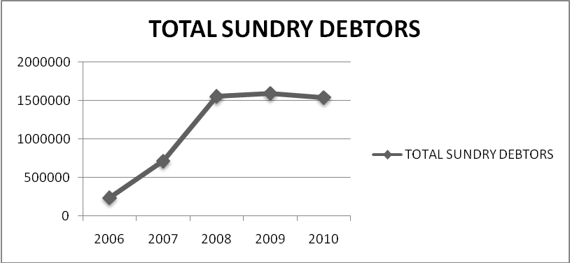

On year to year basis debtors shows an increasing trend although the company has slightly low debtors as at 2010 which also witnessed major increase in sales. Which means realizations shows a positive trend & that the company is able to collect funds from the market on time. Effective increase in %age of debtors is much less than the increase in sales. A positive contribution towards working capital.

CHAPTER 6
DATA INTERPRETATION AND ANALYSIS

DATA ANALYSIS
DATA is analysed according to the financial reports of LUMINOUS POWER TECHNOLOGIES PVT LTD. for the last five financial years. The analysis has been done on the basis secondary data.
Tools/indicator
- Working capital cycle
- Schedule of change in working capital
- Balance Sheet comparison.
- Ratio Analysis.
ANALYSIS OF RATIOS

The ratio analysis has emerged as the principle technique of the analysis of financial statement. Ratio is a relationship expressed in mathematical terms between two individual or group of figures connected with each other in some logical manner. The ratio analysis is based on the premise that a single accounting figure by itself may not communicate any meaningful information but when expressed as a relative to some other figure, it may definitely give some significant information. The relationship between two or more accounting figures/groups is called a financial ratio.

A financial ratio helps to summarize a large mass of financial data into a concise form and to make meaningful interpretations and conclusions about the performance and position of an organization.

Financial ratios are useful by product of financial statement and provide standardized measures of organizations’ financial position, profitability and riskiness. It is an important and powerful tool in the hands of a financial analyst. The objective in using a ratio when analyzing financial information is simply to standardize the information being analyzed so that comparisons can be made between two ratios of different organizations or possibly of the same organization at the different points in time.

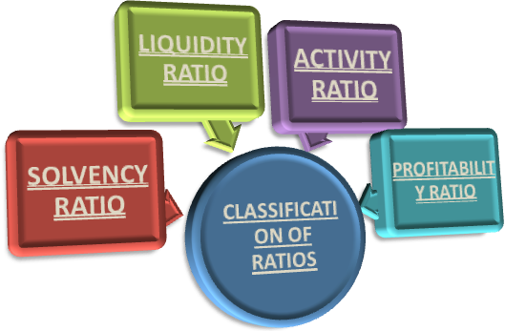

LIQUIDITY RATIO

Liquidity refers to the maintenance of cash and bank balance and those assets which are easily convertible into cash in order to meet the liabilities as and when arises. So, the liquidity ratios study the organizations’ short term solvency and its ability to pay off the liability.

The liquidity ratios provide quick measures of liquidity of the organization by establishing a relationship between its current assets and its current liabilities. If a organization does not have sufficient liquidity, it may not be in a position to meet its commitments and thereby may loose its credit worthiness.
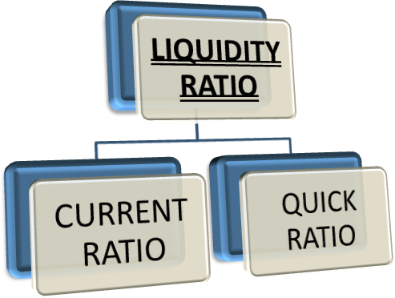

There are two types of liquidity ratios

1. CURRENT RATIO:
It is the most common and popular measure of studying the liquidity of a organization. It is calculated as follows:
CURRENT RATIO= CURRENT ASSETS/ CURRENT LIABILITIES
The total current assets include those assets which are in the form of cash, near cash or convertible into cash within a period of one year. The term current assets also include prepaid expenses and short term investments. The current liability includes all types of liabilities which will mature for payment within a period of one year e.g. bank overdrafts, bills payable, trade creditors etc.
Generally current ratio of 2 times or 2:1 is considered to be satisfactory, though it is not applicable to all cases. This standards current ratio may vary from one industry to another and therefore a organization’s current ratio should be compared with the standards for the specific industry only.
2. QUICK RATIO:
It is also called acid test ratio or liquid ratio. This ratio establishes the relationship between quick current assets and the current liabilities. The current assets are considered to be quick if it is convertible into cash without loss of time and value. On the basis of this definition of quick assets, the inventory is singled out of total current assets as the inventory is considered to be potentially illiquid.
Generally a quick ratio of 1:1 is considered to be satisfactory because this means that quick of the organization are just equal to the quick liabilities and there does not seem to be a possibility of default in payment by the organization. The quick ratio may calculate as follows:

QUICK RATIO = QUICK ASSETS/ CURRENT LIABILITIES

TABLE NO.: 5.1
Calculation of Liquidity Ratios
Year | Current assets | Current liabilities | Current ratio | Liquidity ratio
2006 | 473791 | 433229 | 1.09 | 0.65
2007 | 1265608 | 1150014 | 1.1 | 0.71
2008 | 2608333 | 1529093 | 1.71 | 1.18
2009 | 2614118 | 1362893 | 1.92 | 1.38
2010 | 2954738 | 1939624 | 1.52 | 1.04
Source: Compiled From Balance Sheet Of Luminous

FIGURE NO.: 5.1
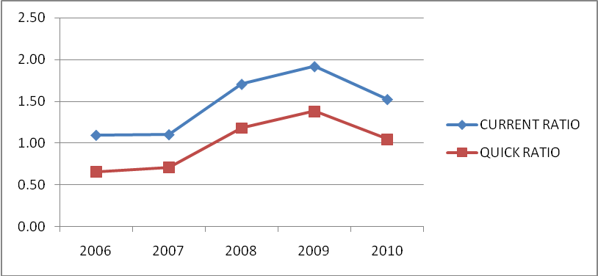

Interpretation:-
Current Ratio- Luminous maintains the proper balance between the current assets and current liabilities i.e. 2:1 in the organization. Higher the ratio, the firm has greater chance/ability to pay its bills. So current ratio of Luminous is approximately good over the years means they have sufficient funds to pay bills on time. Luminous also maintains their liquidity by consisting more cash as well as current receivables then inventories.

Quick Ratio- shows a loop sided trend initially reaching to the satisfactory level i.e. 1:1 in year 2010. Over the last few years, Luminous mainly concentrates on paying bills or meeting expenses quickly by maintaining healthy liquid ratio.

SOLVENCY RATIO

Solvency of business related to its debt paying capacity. With the help of liquidity ratios, short term solvency of business can be analyzed. Under this head, long term solvency of business has been analyzed. Normally the ordinary share holders, debenture holders, financial institutions and other long term creditors are interested in these ratios. With the help of these ratios, long term creditors can analyze the capacity of business to take interest and principal. Long term solvency of business means its ability to pay the long term debts and interest thereon regularly. Therefore, the long term solvency or financial position has two aspects:
- The ability to repay principal on due date.
- The ability to pay interest regularly.
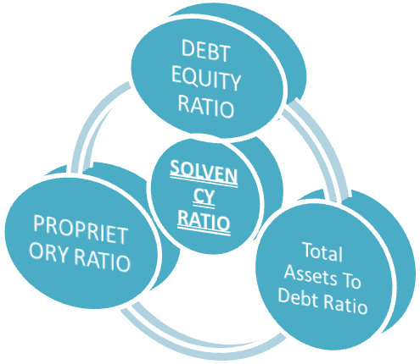

These are the important ratios falls under the solvency ratio:
- DEBT EQUITY RATIO: the debt equity ratio is the basic and most common measure of studying the indebt ness of the organization. The D/E ratio is based on the assumption that the extent to which an organization should employ the debt should be viewed in the terms of the size of the cushion provided by the shareholders’ funds. The D/E ratio is calculated as under:
DEBT EQUITY RATIO = LONG TERM LOANS / EQUITY
TABLE NO.: 5.2
Debt Equity Ratio
Year | Loans | Equity | Debt Equity Ratio
2006 | 175778 | 83471 | 2.11
2007 | 444870 | 303973 | 1.46
2008 | 383029 | 1552986 | 0.25
2009 | 599942 | 1805441 | 0.33
2010 | 601155 | 2209057 | 0.27
Source: Compiled From Balance Sheet

Interpretation:- As the table state, the debt-equity ratio of the company is 2.11 in year 2006 which indicates that the organization had long term borrowing in comparison to funds provided by shareholders and it indicates a financial risk. However, in the year 2009 & 2010 the debt equity ratio of company is at the much more stable position i.e., 0.33 & 0.27 respectively.

- TOTAL ASSETS TO DEBT RATIO:
This ratio is a variation of debt equity ratio and gives the same indication as the debt equity ratio. In this ratio, total assets are expressed in relation to long term debts.
This ratio measures the extent to which long term loans are covered by assets which indicates the margin of safety available to providers of long term loans. A higher total assets to debt ratio implies the use of lower debts in financing the assets which means a larger safety margin for lenders. On the other hand, low ratio represents risky financial position as it implies the use of higher debts in financing the assets of the business.

TOTAL ASSETS TO DEBT RATIO = TOTAL ASSETS/ LONG TERM LOANS
TABLE NO.: 5.3
Total Assets To Debt Ratio
Year | Total assets | Loans | Total Assets To Debt Ratio
2006 | 641149 | 175778 | 3.65
2007 | 1594732 | 444870 | 3.58
2008 | 3223155 | 383029 | 8.41
2009 | 3364138 | 599942 | 5.61
2010 | 4400213 | 601155 | 7.32
Source: Compiled From Balance Sheet

Interpretation:- The total assets to debt ratio is 3.65 in year 2006 which indicates that the organization has used lower debts in financing the assets which means safety margin for lenders. However, in the year 2008 & 2010 the organization maintains their highest total assets to debt ratio i.e. 8.41 & 7.32 respectively.

3. PROPRIETORY RATIO:
Shareholder's funds include equity share capital plus all reserves and surpluses items. Total assets include all assets, including Goodwill. Some authors exclude goodwill from total assets. In that case the total shareholder's funds are to be divided by total tangible assets. As the total assets are always equal to total liabilities, the total liabilities, may also be used as the denominator in the below formula. It may be calculated as under:
PROPRIETORY RATIO= EQUITY / TOTAL ASSETS
This ratio throws light on the general financial strength of the company. It is also regarded as a test of the soundness of the capital structure. Higher the ratio or the share of shareholders in the total capital of the company better is the long-term solvency position of the company. A low proprietary ratio will include greater risk to the creditors.

TABLE NO.: 5.4
PROPRIETORY RATIO
Year | Total assets | Equity | Proprietory Ratio
2006 | 641149 | 83471 | 0.13
2007 | 1594732 | 303973 | 0.19
2008 | 3223155 | 1552986 | 0.48
2009 | 3364138 | 1805441 | 0.53
2010 | 4400213 | 2209057 | 0.5
Source: Data Collected From Balance Sheet

Interpretation:- The proprietary ratio is 0.13 in year 2006 which indicates that the organization has very small proportion of total assets which is provided by equity i.e. the organization is more dependent on external sources of finance. In the meantime after 2008 organization’s maintained sound proprietary ratio i.e. approx. 0.50 which means the organization has a healthy financial position from long term point of view.
FIGURE NO.: 5.2
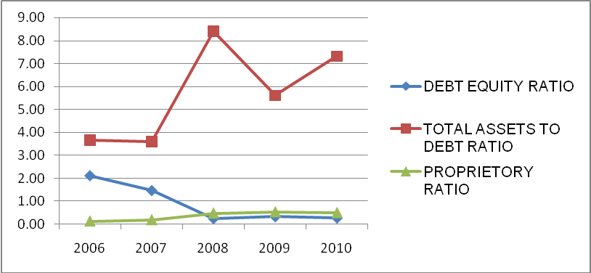

ACTIVITY RATIO

Activity ratios are measures of efficient management of various assets. The effective utilisation of these assets depends on the speed at which these assets are converted in sales. Higher velocity of their conversion in sales indicates that assets are being efficiently managed. Thus, activity ratios measure the rate of change of assets in sales. These ratios are also known as turnover ratios or performance ratios. These ratios are of various types according to the nature of assets. They can be explained as follows:

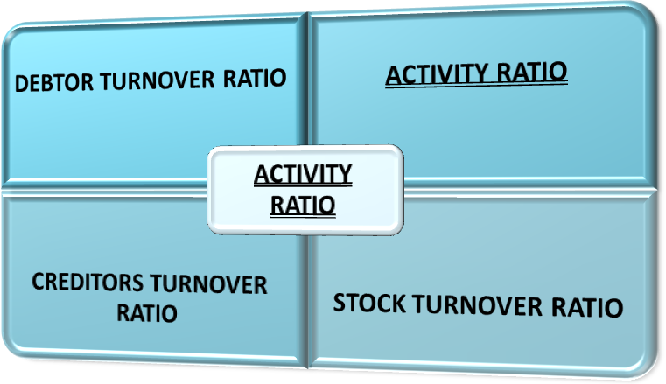

- STOCK TURNOVER RATIO
Stock turn over ratio and inventory turn over ratio are the same. This ratio is a relationship between the cost of goods sold during a particular period of time and the cost of average inventory during a particular period. It is expressed in number of times. Stock turn over ratio / Inventory turn over ratio indicates the number of time the stock has been turned over during the period and evaluates the efficiency with which a organization is able to manage its inventory. This ratio indicates whether investment in stock is within proper limit or not.
Inventory turnover ratio measures the velocity of conversion of stock into sales. Usually a high inventory turnover/stock velocity indicates efficient management of inventory because more frequently the stocks are sold; the lesser amount of money is required to finance the inventory. A low inventory turnover ratio indicates an inefficient management of inventory. A low inventory turnover implies over-investment in inventories, dull business, poor quality of goods, stock accumulation, accumulation of obsolete and slow moving goods and low profits as compared to total investment. The inventory turnover ratio is also an index of profitability, where a high ratio signifies more profit; a low ratio signifies low profit. Sometimes, a high inventory turnover ratio may not be accompanied by relatively high profits. Similarly a high turnover ratio may be due to under-investment in inventories. It is calculated as follows:
STOCK TURNOVER RATIO= NET SALES / AVERAGE STOCK

It may also be mentioned here that there are no rule of thumb or standard for interpreting the inventory turnover ratio. The norms may be different for different organizations depending upon the nature of industry and business conditions. However the study of the comparative or trend analysis of inventory turnover is still useful for financial analysis.
TABLE NO.: 5.5
STOCK TURNOVER RATIO
Year | Net sales | Average Stock | Stock turnover ratio
2006 | 1126183 | 140047 | 8.04
2007 | 2481046 | 320374 | 7.74
2008 | 4110784 | 626143.5 | 6.57
2009 | 4819601 | 766624 | 6.29
2010 | 6422097 | 829808.5 | 7.74
Source: Data Taken From Annual Report Of Luminous

Interpretation:- In the above table, the stock turnover ratio is 8.04 times in year 2006 which shows that the organization’s stock is selling quickly. In this case where stock turnover ratio is high the goods can be sold at a low margin of profit and even then the profitability may be quite high. Wherever, after year 2008 onwards the organization maintains stable stock turnover ratio i.e. around 7 times which seems company is not being able to sale their stock repeatedly.
- DEBTOR TURNOVER RATIO
The two basic components of accounts receivable turnover ratio are net credit annual sales and average trade debtors. The trade debtors for the purpose of this ratio include the amount of Trade Debtors & Bills Receivables. The average receivables are found by adding the opening receivables and closing balance of receivables and dividing the total by two. It should be noted that provision for bad and doubtful debts should not be deducted since this may give an impression that some amount of receivables has been collected. But when the information about opening and closing balances of trade debtors and credit sales is not available, then the debtors turnover ratio can be calculated by dividing the total sales by the balance of debtors (inclusive of bills receivables) given and formula can be written as follows:
DEBTOR TURNOVER RATIO= NET SALES / AVERAGE DEBTORS
Accounts receivable turnover ratio or debtor’s turnover ratio indicates the number of times the debtors are turned over a year. The higher the value of debtor’s turnover the more efficient is the management of debtors or more liquid the debtors are. Similarly, low debtors turnover ratio implies inefficient management of debtors or less liquid debtors. It is the reliable measure of the time of cash flow from credit sales. There is no rule of thumb which may be used as a norm to interpret the ratio as it may be different from organization to organization.
TABLE NO.: 5.6
DEBTOR TURNOVER RATIO
Year | Net sales | Debtors | Debtors turnover ratio | Debtors velocity (days)
2006 | 1126183 | 240298 | 7.27 | 50
2007 | 2481046 | 733579 | 5.05 | 72
2008 | 4110784 | 1587383 | 3.57 | 102
2009 | 4819601 | 1642117 | 3.06 | 119
2010 | 6422097 | 1622460 | 4.1 | 89
Source: Data Compiled From Balance Sheet & P/L Account

Interpretation:- The debtor turnover ratio in the year 2006 is 7.27 times which shows that the amount is being collected from debtors more quickly. The more quickly the debtors pay, the less the risk from bad debts, and so the lower the expenses of collection and increase in the liquidity of the organization. Moreover, this ratio is less in 2009 & 2010 i.e. 3.06 times & 4.10 times respectively indicates the inefficient credit sales policy of the management.
- CREDITORS TURNOVER RATIO
This ratio is similar to the debtor’s turnover ratio. It compares creditors with the total credit purchases. It signifies the credit period enjoyed by the organization in paying creditors. Accounts payable include both sundry creditors and bills payable. Same as debtors turnover ratio, creditors turnover ratio can be calculated in two forms, creditors turnover ratio and average payment period.
CREDITORS TURNOVER RATIO= NET PURCHASES / AVERAGE CREDITORS
The average payment period ratio represents the number of days by the organization to pay its creditors. A high creditor’s turnover ratio or a lower credit period ratio signifies that the creditors are being paid promptly. This situation enhances the credit worthiness of the company. However a very favorable ratio to this effect also shows that the business is not taking the full advantage of credit facilities allowed by the creditors.
TABLE NO.: 5.7
CREDITORS TURNOVER RATIO
Year | Net purchases | Creditors | Creditors turnover ratio | Creditors velocity (days)
2006 | 901353 | 255054 | 5.11 | 71
2007 | 1884942 | 610885 | 4.35 | 84
2008 | 3045514 | 931556 | 3.95 | 92
2009 | 3318097 | 594027 | 4.35 | 84
2010 | 4531411 | 1029569 | 5.58 | 65
Source: Data Taken From Balance Sheet & P/L Account

Interpretation:- The creditor turnover ratio always shows the velocity of debt payment of the organization. The debt payment to the suppliers is decreasing year on year basis. This means the organization was able to evaluate its credit policy by comparing the credit period allowed by the suppliers.

4. WORKING CAPITAL TURNOVER RATIO
Working capital turnover ratio indicates the velocity of the utilization of net working capital. The two components of the ratio are cost of sales and the net working capital. If the information about cost of sales is not available the figure of sales may be taken as the numerator. Net working capital is found by deduction from the total of the current assets the total of the current liabilities. It calculated as follows:
WORKING CAPITAL TURNOVER RATIO=SALES / NET WORKING CAPITAL
The working capital turnover ratio measures the efficiency with which the working capital is being used by a organization. A high ratio indicates efficient utilization of working capital and a low ratio indicates otherwise. But a very high working capital turnover ratio may also mean lack of sufficient working capital which is not a good situation.

TABLE NO.: 5.8
WORKING CAPITAL TURNOVER RATIO
Year | Cost Of Goods Sold | Net Working Capital | Working capital turnover ratio
2006 | 1126183 | 40562 | 27.76
2007 | 2481046 | 115594 | 21.46
2008 | 4110784 | 1079240 | 3.81
2009 | 4819601 | 1251225 | 3.85
2010 | 6422097 | 1015114 | 6.33
Source: Data Compiled From Balance Sheet & P/L Account

Interpretation:- The higher working capital turnover ratio lower is investment in working capital and higher would be the profitability of the organization. Hence, the organization working capital would lead to the profitability of the firm on year to year basis.
FIGURE NO.: 5.3
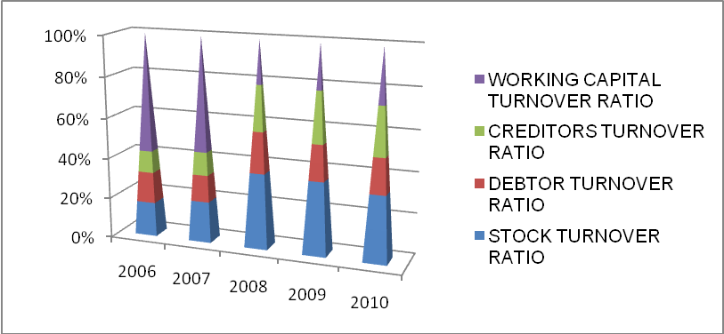

PROFITABILITY RATIO:

The main objective of this ratio is to know whether the business is earning adequate return on the capital invested or not. On the basis of these ratios, the performance of the business can be measured. Sometimes, the profitability ratios based on sales are high but low on the basis of investments. Business collects funds from various sources to earn profits. Therefore, it becomes essential to make proper use of these resources. These ratios are also known as return on investment or ROI. The various profitability ratios are as follows:

- GROSS PROFIT RATIO
The basic components for the calculation of gross profit ratio are gross profit and net sales. Net sales mean those sales minus sales returns. Gross profit would be the difference between net sales and cost of goods sold. Cost of goods sold in the case of a trading concern would be equal to opening stock plus purchases, minus closing stock plus all direct expenses relating to purchases. In the case of manufacturing concern, it would be equal to the sum of the cost of raw materials, wages, direct expenses and all manufacturing expenses. In other words, generally the expenses charged to profit and loss account or operating expenses are excluded from the calculation of cost of goods sold.
GROSS PROFIT RATIO= (GROSS PROFIT / NET SALES)*100
Gross profit ratio may be indicated to what extent the selling prices of goods per unit may be reduced without incurring losses on operations. It reflects efficiency with which a organization produces its products. As the gross profit is found by deducting cost of goods sold from net sales, higher the gross profit better it is. There is no standard GP ratio for evaluation. It may vary from business to business. However, the gross profit earned should be sufficient to recover all operating expenses and to build up reserves after paying all fixed interest charges and dividends.

TABLE NO.: 5.9
GROSS PROFIT RATIO
Year | Gross Profit | Net Sales | Gross Profit Ratio
2006 | 109539 | 1126183 | 9.73
2007 | 236014 | 2481046 | 9.51
2008 | 600826 | 4110784 | 14.62
2009 | 1435400 | 4819601 | 29.78
2010 | 1507887 | 6422097 | 23.48
Source: Data Taken From Auditors Report

Interpretation:- From the above table in gross profit ratio it is analyzed that in the year 2006 it is 9.73% which is quite low but later onwards it starts increasing to 29.78% in the year 2009 which is quite better for the organization. But due to price of manufacturing expenses may have grown up in the last year 2010 it reaches 23.48%.

- NET PROFIT RATIO
Net profit ratio is the ratio of net profit (after taxes) to net sales. It is expressed as percentage. The two basic components of the net profit ratio are the net profit and sales. The net profits are obtained after deducting income-tax and, generally, non-operating expenses and incomes are excluded from the net profits for calculating this ratio. Thus, incomes such as interest on investments outside the business, profit on sales of fixed assets and losses on sales of fixed assets, etc are exclude.
NET PROFIT RATIO= (NET PROFIT / NET SALES)*100
NP ratio is used to measure the overall profitability and hence it is very useful to proprietors. The ratio is very useful as if the net profit is not sufficient, the organization shall not be able to achieve a satisfactory return on its investment.
This ratio also indicates the organization's capacity to face adverse economic conditions such as price competition, low demand, etc. Obviously, higher the ratio the better is the profitability. But while interpreting the ratio it should be kept in mind that the performance of profits also be seen in relation to investments or capital of the organization and not only in relation to sales.

TABLE NO.: 5.10
NET PROFIT RATIO
Year | Net Profit | Net Sales | Net Profit Ratio
2006 | 28994 | 1126183 | 2.57
2007 | 249041 | 2481046 | 10.04
2008 | 586050 | 4110784 | 14.26
2009 | 405880 | 4819601 | 8.42
2010 | 548715 | 6422097 | 8.54
Source: Data Compiled From Balance Sheet And P/L Account

Interpretation: - In net profit ratio it is 2.57% in the year 2006 which helps in determining the overall efficiency of the business operations. Later on it get increased from 8.42% in the year 2008 to 8.54% in the year 2010, indicates the improvement in the overall efficiency and profitability of the business
figure no.: 5.4
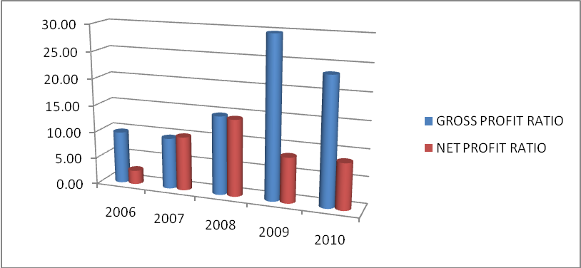
.

SWOT ANALYSIS
STRENGTHS:-
- The co. is having excellent market standing & experience due to in depth knowledge.
- Product reliability and quality driven through technology and engineering.
- Good Pre-sales, project, technical & post- sales manpower.
- Smart and effective marketing and communication for brand building.
- Continuous expansion of our distribution network to increase reach in the market.
- Competitive price offerings through product innovation, integrated manufacturing and supply chain.

WEAKNESS:
- A high creditor’s turnover ratio signifies that the creditors are being paid promptly. This situation enhances the credit worthiness of the company. From the year 2006, the CTR has been declined in 2010…which means cash has been eaten up.
- Missing expertise in some areas viz. R&D.

OPPORTUNITIES:-
- Increase in paying capacity of consumers in smaller towns and villages.
- Energy consumption per capita will grow through use of more gadgets.
- Growth in industrialization will change the demand-supply equation of
Power.
- Renewable energy solutions will be more viable with cost coming down.
THREATS:-
- Larger competitors traditionally capture majority of market share.
- Contractors have little loyalty.
- Small cos. are entering into this sector as per the growing needs and demands of the market in rural & semi-urban areas.

CHAPTER- 7
FINDINGS & SUGGESTIONS

FINDINGS OF THE PROJECT

- RATIOS :

- LIQUIDITY RATIO
(i) Current Ratio (ii) Quick Ratio
- SOLVENCY RATIO

(i) Debt equity Ratio (ii) Proprietary Ratio (iii) Total Assets to Debt Ratio

- ACTIVITY RATIO
(i) Stock Turnover Ratio (ii) Debtors Turnover Ratio
(iii) Creditors Turnover Ratio (iv) Working Capital Turnover Ratio
- PROFITABILITY RATIO
(i)Net Profit Ratio (ii) Gross Profit Ratio
2. COMPARATIVE BALANCE SHEET OF YEAR 2009 & 2010
3. WORKING CAPITAL CYCLE:
a) WIP CONVERSION PERIOD
b) RAW MATERIAL CONVERSION PERIOD
c) FG CONVERSION PERIOD
d) DEBTORS CONVERSION PERIOD
e) CREDITOR CONVERSION PERIOD
4. SCHEDULE OF CHANGE IN WORKING CAPITAL:
a) Increase or decrease in current assets
b) Increase or decrease in current liabilities

SUGGESTIONS
1. In order to achieve competitive advantage company should try to improve sale service and take feedback from the customers in order to give more satisfaction to its customers for further improvements.
2. Luminous can increase their market share by moving their network to rural areas on the affordable price to the customers.
3. Debtors Position:
- It has a very high percentage of debtors in comparisons to its net sales.
- The debtor’s conversion period of the company is more than 4 months & 3 months in year 2009 & 2010 respectively. Company should focus on minimizing the debtors conversion period.
4. Creditors Position:
- Creditors of the company shows an increase in 2010 as compared to 2009 this may be due to the procurement of raw material to meet increase in production level in order to meet higher sales.
- The creditor’s conversion period of Luminous is around 2~3 months for the last five years. The debt payment to the suppliers is decreasing year on year basis. This means the organization was able to evaluate its credit policy by comparing the credit period allowed by the suppliers. It would be good sign for the company.
5. Inventory Position
- Company maintains less finished goods in year 2009 in order to save carrying and storage cost.
- The organization stock turnover ratio is high goods can be sold at a low margin of profit and even then the profitability may be quite high on year to year basis.

CHAPTER- 8
CONCLUSION

CONCLUSION

Any change in the Luminuous Power working capital will have an effect on a business's cash flows. A positive change in working capital indicates that the business has paid out cash, for example in purchasing or converting inventory, paying creditors etc. Hence, an increase… in working capital will have a negative effect on the business's cash holding. However, a negative change in working capital indicates lower funds to pay off short term liabilities (current liabilities), which may have bad repercussions to the future of the Luminous or any other company.

BIBLIOGRAPHY

(A) Books:
1. Financial Management Theory, Concepts & Problems – By R.P.Rustagi (1999 – Edition).
2. Management Accounting and Financial Management – By Dr. R. K. Mittal.(2006-2007 Edition).
3. Analysis of Financial Statement – By D.K.Goel, Rajesh Goel, Shelly Goel. (2009-2010 Edition).
4. Financial Policy and Management Accounting – By Bhabatosh Banerjee (2005 Edition).

(B) Website:
1. www.luminousindia.com
2. www.google.com

(C) Brochures
(D) Annual Report Of Luminous (2006 ~ 2010)

Annexure

COMPARATIVE BALANCE SHEET
as at 31st march 2009 and 2010

PARTICULARS | 2009 | 2010 | INC. or DEC. | % INC. or DEC.
CURRENT ASSETS:
Inventories | 731159 | 928458 | 197299 | 26.98
Sundry debtors | 1594987 | 1540881 | -54106 | -3.39
Cash & bank bal. | 157091 | 349111 | 192020 | 122.23
Other current assets | 4527 | 2821 | -1706 | -37.68
TOTAL | 2487764 | 2821271 | 333507 | 13.40
Loans & advances | 339729 | 679980 | 340251 | 100.15
Deferred tax assets | 26042 | 57969 | 31927 | 122.59
Investment | 72282 | 204076 | 131794 | 182.33
Fixed assets :
Land | 13459 | 13459 | 0
Building | 129405 | 192609 | 63204 | 48.84
Building leasehold | 18634 | 17916 | -718 | -3.85
Computer | 5328 | 10664 | 5336 | 100.15
Furniture | 10201 | 13484 | 3283 | 32.18
Plant & machinery | 186059 | 354174 | 168115 | 90.35
Vehicles | 8458 | 12479 | 4021 | 47.54
Other fixed assets | 14496 | 17734 | 3238 | 22.33
Net Fixed Assets | 386040 | 632519 | 246479 | 63.84
Capital WIP | 78323 | 62367 | -15956 | -20.37
GRAND TOTAL | 3390180 | 4458182 | 1068002 | 31.50
LIABILITIES& CAPITAL:
Current liabilities
Creditors for goods | 594027 | 1029569 | 435542 | 73.32
Crs. Capital goods | 11960 | 28076 | 16116 | 134.74
Book overdrafts | 4867 |  | -4867 | -100
Advance from customers | 24981 | 44280 | 19299 | 77.25
Security deposits | 31670 | 30270 | -1400 | -4.42
Statutory liabilities | 45976 | 82438 | 36462 | 79.30
Other liabilities | 59129 | 93245 | 34116 | 57.69
Provision | 212187 | 340092 | 127905 | 60.27
TOTAL | 984797 | 1647970 | 663173 | 67.34
Loan funds
Secured loans | 599942 | 601155 | 1213 | 0.20
Capital & reserves
Share capital | 618785 | 618785 | 0 | 0
Reserves & surplus | 1186656 | 1590272 | 403616 | 34.01
TOTAL SHAREHOLDERS
FUNDS | 2405383 | 2810212 | 404829 | 16.83
TOTAL LIAB. & CAP. | 3390180 | 4458182 | 1068002 | 31.50
SCHEDULE OF CHANGE IN WORKING CAPITAL

PARTICULARS | 2009 | 2010 | INCREASE | DECREASE
CURRENT ASSETS:
CASH & BANK BALANCES | 157091 | 349111 | 192020
SUNDRY DEBTORS | 1594987 | 1540881 |  | 54106
INVENTORIES | 731159 | 928458 | 197299
TOTAL OTHER CURRENT ASSETS | 130881 | 136288 | 5407
TOTAL CURRENT ASSETS | 2614118 | 2954738
CURRENT LIABILITIES:
SUNDRY CREDITORS | 594027 | 1029569
BANK OVERDRAFT | 4867 | 0 | 4867
ADVANCE FROM CUSTOMERS | 24981 | 44280 |  | 435542
OTHER LIABILITY | 526831 | 525683 | 1148
PROVISION | 212187 | 340092 |  | 19299
TOTAL CURRENT LIABILITIES | 1362893 | 1939624
NET WORKING CAPITAL (CA- CL) | 1251225 | 1015114 |  | 127905
NET DECREASE IN WORKING CAPITAL |  | 236111 | 236111
 | 1251225 | 1251225 | 636852 | 636852

Working Capital Cycle Of LUMINOUS
RAW MATERIAL: | 2006 | 2007 | 2008 | 2009 | 2010
OPENING RAW MATERIAL | 2605 | 65711 | 262880 | 352636 | 258624
CLOSING RAW MATERIAL | 65711 | 262880 | 352636 | 258624 | 469857
AVERAGE RAW MATERIAL | 34158 | 164295.5 | 307758 | 305630 | 364240.5
TOTAL RAW MATERIAL | 247116 | 1429380 | 2720898 | 2884693 | 3917804
RAW MATERIAL CONVERSION PERIOD(Days) | 50 | 42 | 41 | 39 | 34
WORK IN PROGRESS: | 2006 | 2007 | 2008 | 2009 | 2010
OPENING WIP | 0 | 56221 | 124089 | 256150 | 171508
CLOSING WIP | 56221 | 124089 | 256150 | 171508 | 194245
AVERAGE WIP | 28110.5 | 90155 | 190119.5 | 213829 | 182876.5
RAW MATERIAL CONSUMED | 247116 | 1429380 | 2720898 | 2884693 | 3917804
PERSONNEL EXPENSES | 59080 | 125911 | 191733 | 282025 | 395730
MANUFACTURING EXPENSES | 14285 | 100442 | 112553 | 137034 | 185500
DEPRECIATION | 24361 | 50606 | 93665 | 157532 | 219630
TOTAL COST OF PRODUCTION | 288621 | 1638471 | 2986788 | 3545926 | 4695927
WIP CONVERSION PERIOD (Days) | 31 | 11 | 11 | 16 | 17
FINISHED GOODS: | 2006 | 2007 | 2008 | 2009 | 2010
OPENING FG | 86939 | 68568 | 63229 | 193303 | 301027
CLOSING FG | 68568 | 63229 | 193303 | 301027 | 264356
AVERAGE FG | 77753.5 | 65898.5 | 128266 | 247165 | 282691.5
COST OF PRODUCTION | 288621 | 1638471 | 2986788 | 3545926 | 4695927
SELLING & ADMINISTRATION EXPENSES | 176915 | 298059 | 416511 | 637369 | 871985
FINANCIAL EXPENSES | 15690 | 53116 | 80370 | 127036 | 85556
TOTAL COST OF SALES | 499597 | 1994985 | 3353595 | 4202607 | 5690139
FG CONVERSION PERIOD (Days) | 57 | 12 | 14 | 21 | 18
DEBTORS: | 2006 | 2007 | 2008 | 2009 | 2010
OPENING DEBTORS | 72228 | 237482 | 745826 | 1555104 | 1594987
CLOSING DEBTORS | 237482 | 745826 | 1555104 | 1594987 | 1540881
AVERAGE DEBTORS | 154855 | 491654 | 1150465 | 1575045.5 | 1567934
TOTAL CREDIT SALES | 1126183 | 2481046 | 4110784 | 4819601 | 6422097
DEBTORS CONVERSION PERIOD (Days) | 50 | 72 | 102 | 119 | 89
CREDITORS: | 2006 | 2007 | 2008 | 2009 | 2010
OPENING CREDITORS | 97563 | 255054 | 610885 | 931556 | 594027
CLOSING CREDITORS | 255054 | 610885 | 931556 | 594027 | 1029569
AVERAGE CREDITORS | 176308.5 | 432969.5 | 771220.5 | 762791.5 | 811798
TOTAL PURCHASE | 901353 | 1884942 | 3045514 | 3318097 | 4631411
CREDITOR CONVERSION PERIOD (Days) | 71 | 84 | 92 | 84 | 64
NET WORKING CAPITAL CONVERSION PERIOD: | 2006 | 2007 | 2008 | 2009 | 2010
RAW MATERIAL CONVERSION PERIOD (Days) | 50 | 42 | 41 | 39 | 34
WIP CONVERSION PERIOD (Days) | 31 | 11 | 11 | 16 | 17
FG CONVERSION PERIOD (Days) | 57 | 12 | 14 | 21 | 18
DEBTORS CONVERSION PERIOD (Days) | 50 | 72 | 102 | 119 | 89
CREDITOR CONVVERSION PERIOD (Days) | 71 | 84 | 92 | 84 | 64
NWCCP (Days) | 117 | 53 | 76 | 111 | 94

